Identity and Access Management (Class II Node)
User Guide

eSurfing Cloud Technology Co., Ltd.

Introduction

Definition
The Identity and Access Management (IAM) service is a foundational service for user permission management, enabling secure control over access and operational permissions for cloud services and resources.
Once the IAM service is activated, it is free to use—you only pay for the cloud services and resources within your account.

Basic Concepts
When using the IAM service, common basic concepts include: Account, IAM User, Relationship Between Account and IAM User, User Group, Credentials, Authorization, Permission, Project, Delegation, and Identity Credentials.
Account
The account you registered when first using eSurfing Cloud serves as the entity for resource ownership and usage billing. It has full access to all owned resources and cloud services, enabling operations such as resetting user passwords and assigning user permissions.
The account cannot be modified or deleted in IAM. You may update account information in the Personal Center on the eSurfing Cloud official website. If you need to delete the account, you can cancel it in the Personal Center.
IAM User
IAM users are created by an account within IAM, typically serving as personnel who operate specific cloud services. They possess independent credentials (passwords and access keys) and utilize resources based on permissions granted by the account.
If you forget an IAM user's login password, you can reset it via eSurfing Cloud's official website under Personal Center > IAM > User.
Relationship Between Accounts and IAM Users
The account and IAM users can be compared to a parent-child relationship. The account is the entity responsible for resource ownership and billing, possessing full permissions over its resources. IAM users are created by the account and can only have the resource usage permissions granted by the account. The account can modify or revoke the usage permissions of IAM users at any time.
Figure: Account and IAM Users
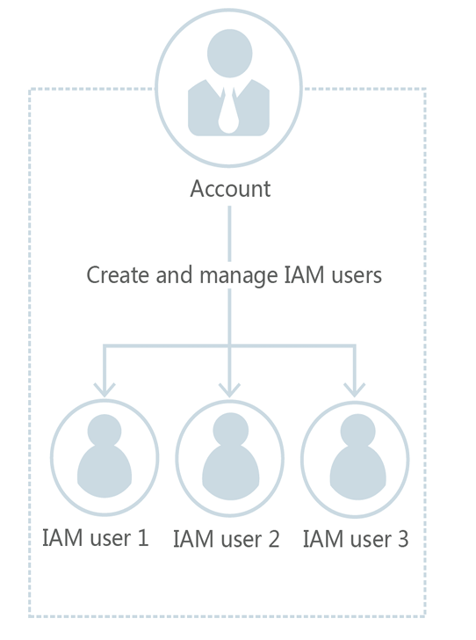

Authorization
Authorization is the process of granting IAM users the necessary permissions to perform specific tasks. It takes effect by defining permission policies. By assigning policies (including system policies and custom policies) to user groups, users within those groups gain the permissions specified in the policies—this entire process is called authorization. Once users obtain permissions for specific cloud services, they can perform operations on those services. For example, they can manage ECS resources within your account.
Figure: Authorization

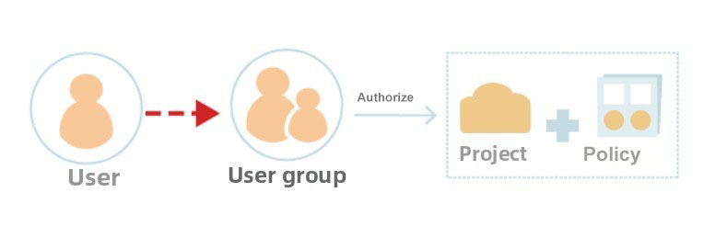
User Group
A user group is a collection of users. IAM leverages user groups to grant permissions to users. The IAM users you create must join specific user groups to obtain corresponding permissions; otherwise, they cannot access any resources or cloud services in your account. When a user joins multiple user groups, they will possess the permissions of all those groups—effectively the union of permissions across all assigned user groups.
The admin is a system-default user group with operational permissions for all eSurfing Cloud service resources. After adding an IAM user to this group, the IAM user can operate and use all cloud resources, including but not limited to creating user groups and users, modifying user group permissions, managing resources, etc.
Figure: User Groups and Users
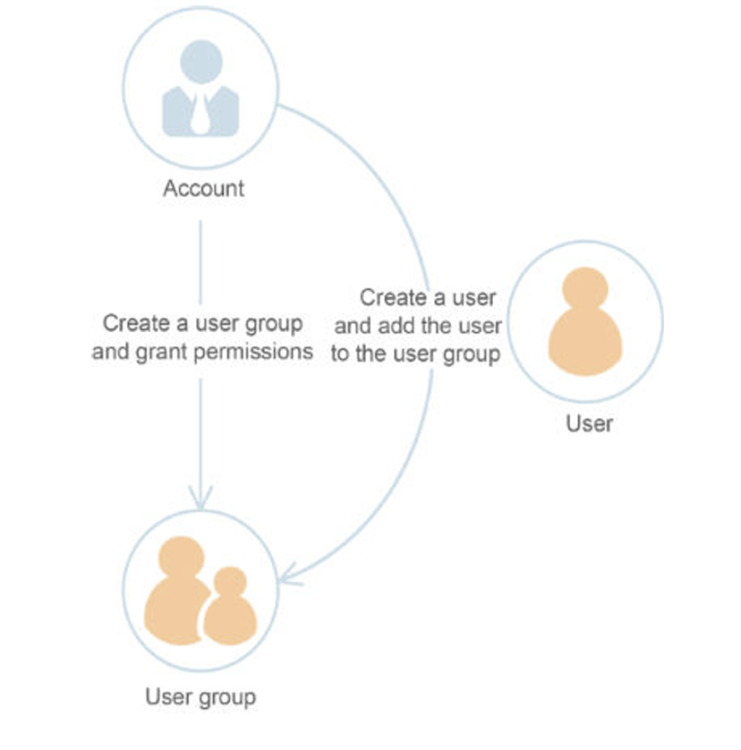

Permissions
If you only grant an IAM user permissions for ECS, that IAM user will not be able to access any other services besides ECS. If they attempt to access other services, the system will display a "No permissions" prompt.
Figure: "No permissions" prompt in the system
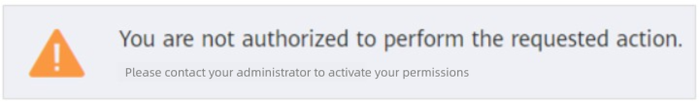
Permissions are divided into policies and roles based on the granularity of authorization.
- Roles: Roles are a coarse-grained authorization capability initially provided by IAM. Currently, some cloud services do not support role-based authorization. Roles cannot fully meet users' requirements for fine-grained permission management.
- Policies: Policies represent IAM's latest fine-grained authorization capability, enabling precise control down to specific actions and conditions. Policy-based authorization offers a more flexible approach to access management, helping enterprises meet least-privilege security requirements. For example, in ECS services, administrators can restrict IAM users to performing only designated management operations on specific types of cloud server resources.
  - Policies include system policies and custom policies.
    - In IAM, common authorization items are predefined for cloud services and are referred to as system policies. When administrators grant permissions to a user group, they can directly use these system policies, which are only available for the application and cannot be modified. If an administrator cannot find the system policy for a specific service when granting permissions to a user group or delegation on the IAM Console because the service does not currently support IAM.
    - If system policies fail to meet authorization requirements, administrators can create custom policies based on the supported authorization items of each service and grant these custom policies to user groups for fine-grained access control. Custom policies serve as an extension and supplement to system policies. Currently, both a visual editor and a JSON view are supported for configuring custom policies.
Figure: Permission Policy Example
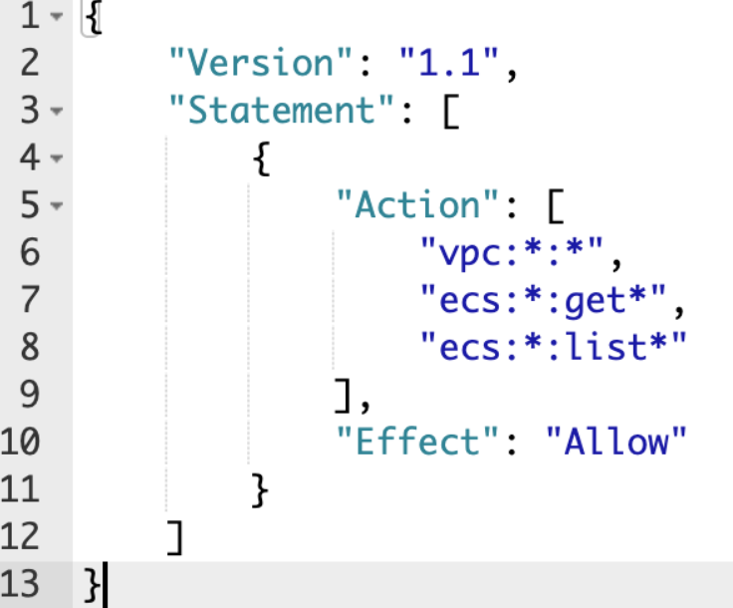

Identity Credentials
Identity credentials serve as the basis for verifying user identity. When accessing cloud services through the console or APIs, you must use identity credentials for system authentication and authorization. Identity credentials include passwords and access keys, which can be managed in IAM for both yourself and the IAM users under your account.
- Password: A common type of identity credential used to log in to the console.
- Access Key: Also known as AK/SK (Access Key ID/Secret Access Key), it serves as the identity credential for calling cloud service APIs and cannot be used to log in to the console. The access key contains a signature for identity verification, ensuring confidentiality, integrity, and the authenticity of both parties in the request through encrypted signature validation.
Project
Each resource pool is associated with a default project, which is preconfigured by the system to isolate resources (such as compute, storage, and network resources) across different resource pools. Authorization is scoped to this default project, allowing users to access all resources within the corresponding resource node (i.e., the default project) in your account.

Delegation
Delegation is divided into delegation to other accounts and delegation to other cloud services based on the different delegation objects.
- Delegate to other eSurfing Cloud accounts: Through the delegation trust feature, you can grant resource operation permissions in your account to another account. The delegated account can perform resource O&M on your behalf based on the assigned permissions.
- Delegate to other cloud services: Due to business interactions between cloud services, certain services may require collaboration with others. In such cases, you can create a cloud service delegation to grant operational permissions, allowing the service to act on your behalf. This enables the service to utilize other cloud services and perform automated resource management tasks for you.

Advantages

Fine-grained Access Control Over Resources
After registration, the system will automatically create an account for you. This account has full control over its owned resources and can access all cloud services in the system.
When you create various resources—such as the Elastic Cloud Server (ECS), Elastic Volume Service (EVS), and Dedicated Physical Server (DPS)—your team or applications may need access to these resources. To facilitate this, you can create IAM users for employees or applications, granting them only the permissions necessary to perform their tasks. Newly created IAM users can log in to the cloud service platform using their own unique username and password. The purpose of IAM users is to enable multi-user collaboration under a single account without the need to share the account password.

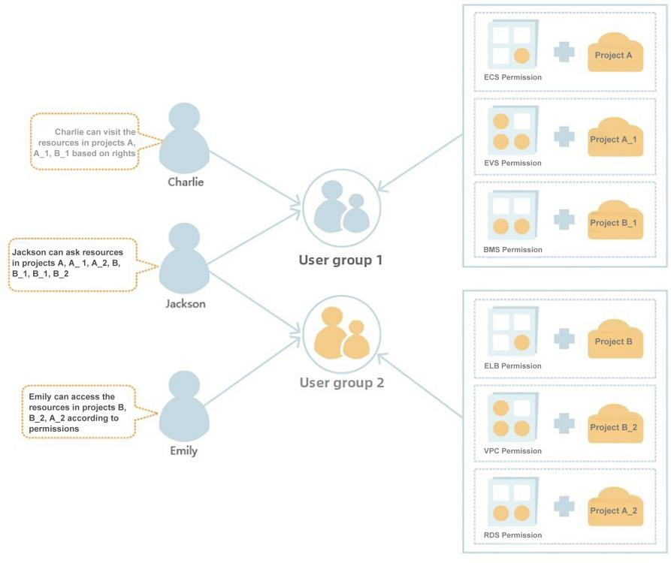

Cross-account Resource Operations and Authorization
If you create multiple resources and want one of them to be managed by another account, you can use the delegation feature provided by IAM.
For example, if you wish to delegate resource O&M to a professional third-party O&M company, IAM's delegation feature allows the company to use its own account to operate the resources you've delegated. Should the delegation relationship change, you can modify or revoke the maintenance company's authorization at any time.
In the diagram below:
- Account A represents the delegating party
- Account B represents the delegated party

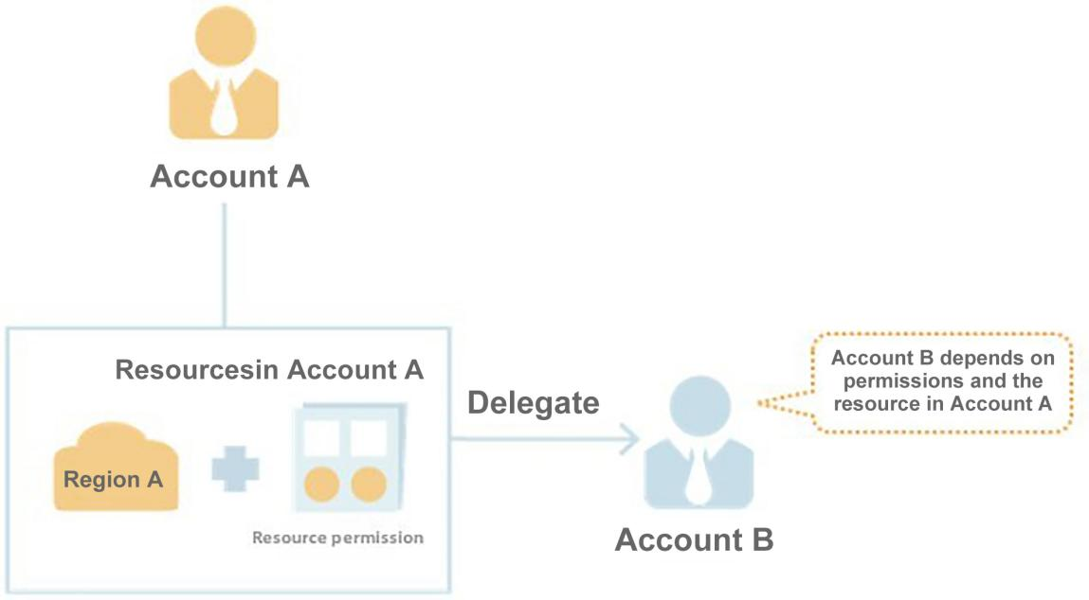

Function
The main features provided by IAM include: fine-grained permission management, secure access, batch management of user permissions through user groups, and delegation of resource management to other accounts or eSurfing Cloud services.
Fine-grained Permission Management
With IAM, you can allocate different resources within your account to create IAM users as needed, enabling fine-grained permission management. For example, you can grant user Charlie permissions to manage the VPCs in Project B, while restricting user James to only view VPC data in Project B.
Figure: Permission Management Model
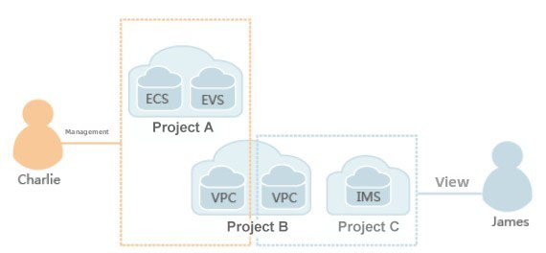
Secure Access
With IAM, you can generate identity credentials for users or applications, eliminating the need to share your account password with others. The system will securely grant access to resources in your account based on the permission details carried in these credentials.
Batch Managing User Permissions Through the User Group
With IAM, you don't need to authorize each user individually. Simply organize user groups, assign permissions to the groups, and then add users to the corresponding groups—users will automatically inherit the group's permissions. If a user's permissions need to be modified, just remove them from one group or add them to another, enabling efficient permission management.
Delegating Other Accounts or Cloud Services to Manage Resources
With the delegation feature, you can assign your operational permissions to more specialized and efficient accounts or eSurfing Cloud services. These trusted entities can then perform routine tasks on your behalf within the scope of the granted permissions.

Usage Limits
Restriction Category | Restriction Item | Restriction Value | Is Modification Supported
User | IAM user count | 50 | √
User | Username length | 32 | x
User | Maximum number of joinable user groups | 10 | x
User | Access key (AK/SK) creation limit per user | 2 | x
User group | Number of user groups | 20 | √
User group | User group name length | 64 | x
User group | User group membership limit | AM users per account | x
User group | IAM project policy quota per user group | 200 | √
Policy | Policy name length | 64 | x
Custom policy | Custom policy quota | 128 | √
Custom policy | Character count | 6144 | x
Custom policy | Statement | 8/policy | x
Custom policy | Action | 100/Statement Action array | x
Custom policy | Resource | 10/Statement Resource array | x
Custom policy | Condition | 10/statement Condition array | x
Delegate | Delegation count | 50 | √
Delegate | Delegation name length | 64 | x
Delegate | Delegation policy attachment limit | 200 | √

Billing Instructions

Resource Node
The eSurfing Cloud resource nodes currently supported by the Identity and Access Management (IAM) service are:
Hong Kong 2, Singapore 1, Indonesia 1, Macau 1, Philippines 1.

Billing Instructions

The IAM service is currently free of charge.

Quick Start

Example Scenarios
You can plan user groups based on user responsibilities. Use the Security Administrator to access IAM and create user groups, then assign corresponding permissions to the user groups according to their responsibilities.
Prerequisite
Please ensure you already have an eSurfing Cloud account. If you do not have one yet, please register first.
Business Scenario
Company A is a website development company with three functional teams. To facilitate centralized resource creation, allocation, and user management, Company A does not require each employee to register an individual account. Instead, the company's administrator registers a single account, creates IAM users under this account, assigns appropriate permissions, and then distributes the IAM users to employees for use.
This section uses Company A's scenario of creating IAM users and user groups as an example to help you quickly understand how enterprises can configure service permissions using IAM.
Staff Composition of Company A
- The management team (corresponding to "Admin" in the diagram below) is responsible for overseeing personnel and resources within the company, including permission assignment and resource allocation. Team members include James and Alice.
- The development team (corresponding to the "Development Team" in the diagram below) is responsible for building the company's website. Team members include Charlie and Jackson.
- The testing team (corresponding to the "Test Team" in the diagram below) is responsible for testing the websites developed by the development team. The team members include Jackson and Emily. Among them, Jackson is involved in both development and testing, so he needs to join both the Development Team and the Test Team to obtain the respective permissions of the two user groups.
Figure: User Management Model
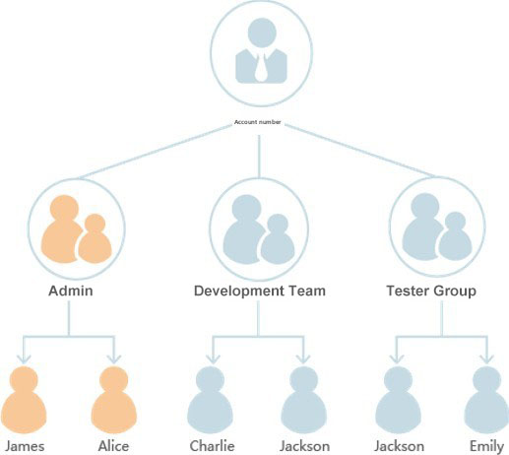

Business Composition of Company A
- The Admin Team is primarily responsible for managing company personnel permissions and needs to use the IAM service.
- The Development Team requires ECS, VPC, and EVS during the website development process.
- The Test Team is mainly responsible for website monitoring and testing, and needs to use the Cloud Eye Service (CES).

User Management Process
- The administrator of Company A logs into eSurfing Cloud using a registered account, creates the Development Team and Test Team, and assigns permissions to these user groups. For detailed steps, see Step 1: Creating User Groups and Assigning Permissions.
- The administrator of Company A then creates IAM users for members of the three functional teams and instructs them to log in to eSurfing Cloud using the newly created IAM accounts. For detailed steps, see Step 2: Creating an IAM User and Logging In.

Creating a User Group and Assigning Permissions
Company A's teams are divided into the Admin Team, Development Team, and Test Team. Since the system has a default built-in Admin Team with full access to manage all account resources, Company A only needs to create the Development Team and Test Team in IAM.
Creating a User Group
Step 1: The administrator of Company A logs into the official eSurfing Cloud website using a registered account.
Step 2: Click the account name in the upper-right corner, then select Personal Center from the dropdown menu.
Step 3: In the left navigation pane of Personal Center, click IAM.
Step 4: In the left navigation pane of the IAM , click User Group.
Step 5: On the User Group management page, click Create User Group in the upper-right corner.
Step 6: Enter the User Group Name and Description, then click Confirm.
After returning to the User Group list page, the newly created user group will be displayed. Follow the same process to create both the Development Team and Test Team.

Granting Permissions to a User Group
Company A's development members require access to cloud services, including ECS, VPC, and EVS. The Development Team is granted administrator permissions for these services. The testing members need access to CES, so the Test Team should be granted corresponding permissions. Only after completing these authorizations can group members access these cloud services.
Step 1: The Company A administrator logs into the eSurfing Cloud official website using a registered account.
Step 2: Click the Management Center at the top of the homepage. Under the Management and Deployment category, select IAM.
Step 3: On the IAM console page, navigate to the left menu and click User Group. Locate the pre-created Development Team, then click Accredit on the right.
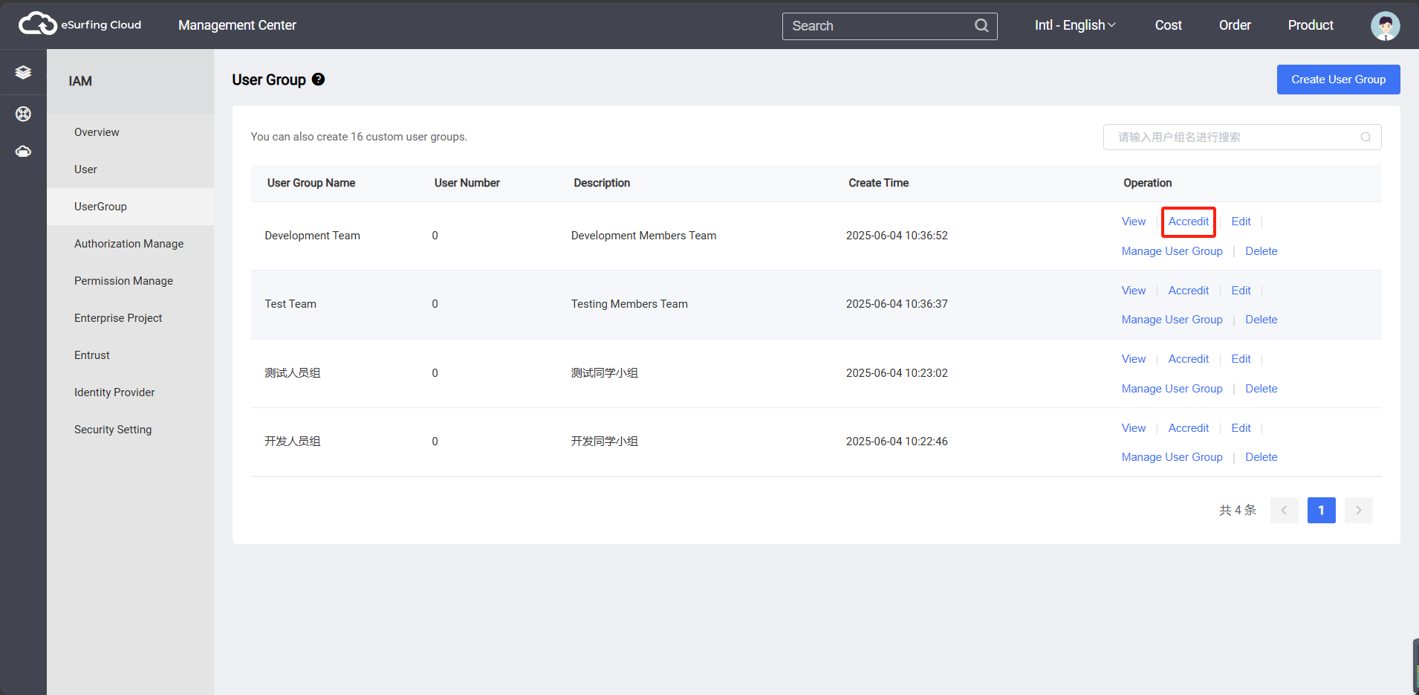
Step 4: On the User Group Permissions Management page, select the service permissions to be granted to the user group. In this example, add the three policy authorizations—ECS Admin, VPC Admin, and EVS Admin—to the Development Team, then click Next.
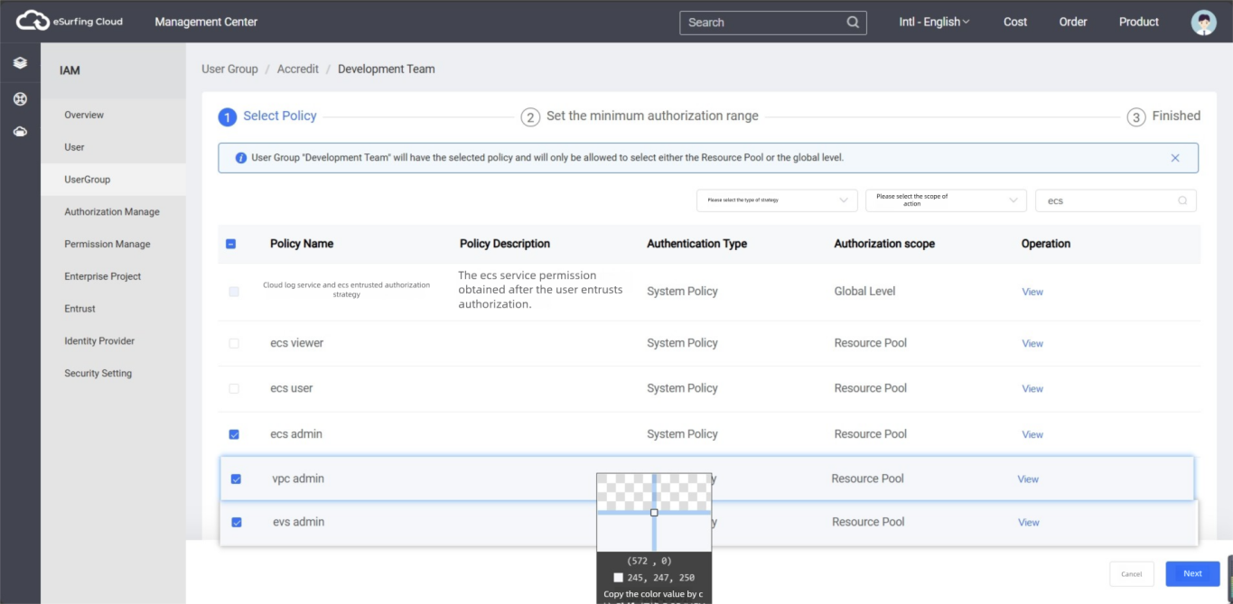
Step 5: Select the authorization scope as Designated resource pool, then choose the target region and project (i.e., the resource pool) to grant permissions. Click Confirm. Once configured, the Development Team will only have operational permissions in the authorized regions. Attempting to access other regions will result in a "No permissions" prompt.
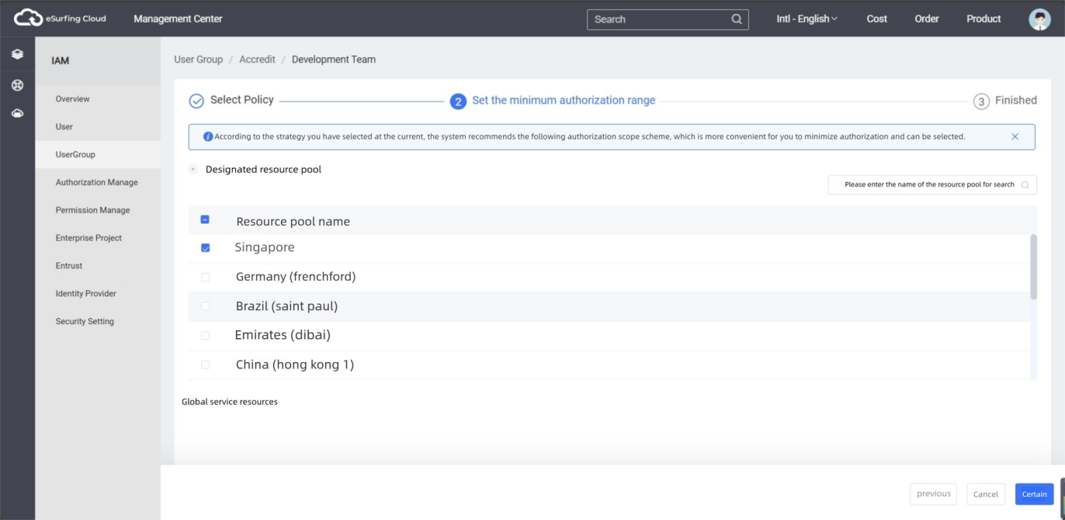
Step 6: Click OK to complete the permission assignment for the user group.
Following the method described in Steps 3 to 5, grant the CES Administrator permission to the Test Team.

Creating an IAM User and Logging In
In Step 1, the user group has been created and authorized. This section describes how Company A uses its registered eSurfing Cloud account to create IAM users for its employees and add them to the user group. This enables employees to have independent usernames and passwords, allowing them to log in to eSurfing Cloud separately and manage resources within their assigned permissions.
Creating an IAM User
Step 1: The administrator of Company A logs in to the eSurfing Cloud official website using the registered eSurfing Cloud account.
Step 2: Click the account name in the upper-right corner, then select Personal Center from the dropdown menu.
Step 3: In the left navigation pane of the Personal Center, click IAM.
Step 4: In the left navigation pane of IAM, click User.
Step 5: On the Users management page, click Create User.
Step 6: On the Create User page, enter user details, including Username, Mobile Number, and User Group.
User Group: From the dropdown menu, select the pre-created Development Team (from Step 1). The new user will inherit all permissions assigned to this group, completing the authorization process.
Basic User Information: Enter the new user's Email Address, Username, and other required details, then set an initial login password.
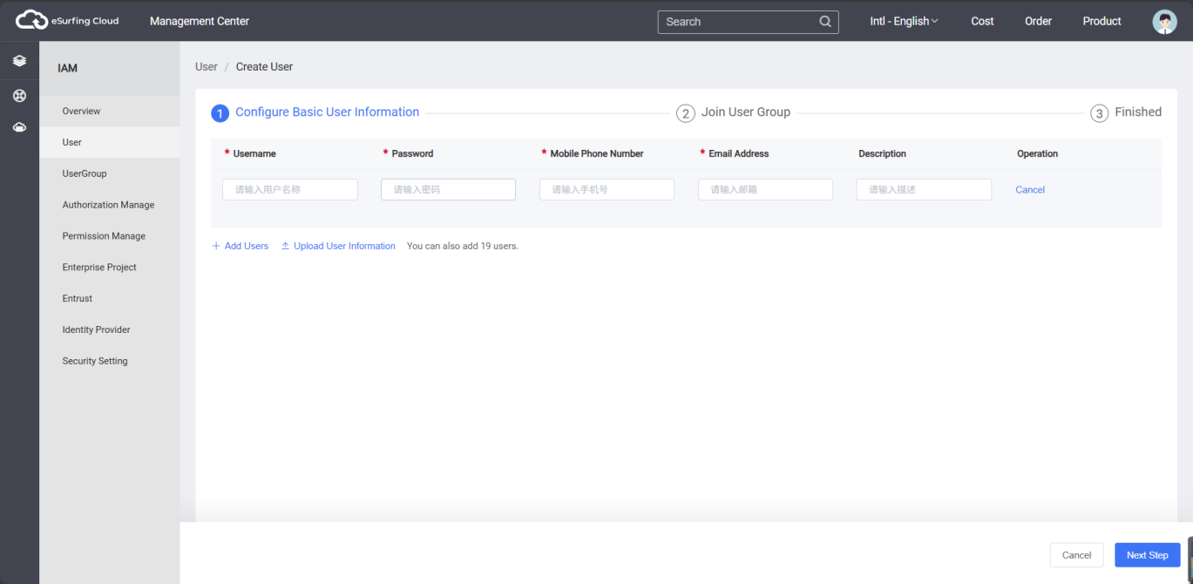
Step 7: Click Confirm to complete the IAM user creation. The newly created IAM user will then appear in the user list.
Following the method described in Steps 5 to 7, proceed to create users Charlie, Jackson, and Emily, and assign them to their respective user groups.

IAM User Login
Through the aforementioned steps, Company A has created IAM users named James, Alice, Charlie, Jackson, and Emily in its eSurfing Cloud account. After completing the IAM user creation, the administrator of Company A needs to notify the corresponding employees of the account name, IAM username, and initial password. These employees can then use their own usernames and passwords to access eSurfing Cloud and various cloud service platforms.
If an IAM user fails to log in or forgets the password, they can contact the administrator of Company A to reset it.
Step 1: The IAM user of Company A opens the official eSurfing Cloud website.
Step 2: Click Login in the upper right corner. On the login page, enter the IAM username (usually an email address) and password, then click the Login button to access eSurfing Cloud.

User Guide

IAM User

Creating an IAM User
If you are an administrator and have created various resources on the cloud service platform—such as ECSs, EVSs, and DPSs—you may need to allocate these resources to different employees or applications within your enterprise. To avoid sharing your own account credentials, you can use the User Management feature on the eSurfing Cloud official website to create IAM users for employees or applications.
By default, a newly created IAM user has no permissions. The administrator needs to explicitly grant permissions to the IAM user, either by assigning individual permissions or by adding the user to a user group and granting permissions to that group. Users within the group will automatically inherit the group's permissions.
Once an IAM user has been granted permissions, they can perform operations on cloud services based on their assigned access rights.
Note:
The admin group is the default user group with operational permissions for all cloud service resources. After adding a user to this group, the user can operate and use all cloud service resources, including but not limited to creating user groups and users, modifying user group permissions, managing resources, etc.
If a user with the same name is deleted and recreated, reauthorization is required.
Procedure
Step 1: The administrator logs in to the eSurfing Cloud official website using a registered eSurfing Cloud account.
Step 2: Click on the account name in the upper-right corner, then select Personal Center from the dropdown menu.
Step 3: In the left navigation pane of the Personal Center, click IAM.
Step 4: In the left navigation pane of IAM, click User.
Step 5: On the Users management page, click Create User.
Step 6: On the Create User page, enter the user's information, including username, mobile phone number, user group, etc.
User Group: Select an existing user group from the dropdown menu. The new user will inherit all permissions of this group, which constitutes user authorization.
Basic User Information: Enter details such as the user's email and username, and set an initial login password.
Step 7: Click Confirm to complete the IAM user creation. The system will return to the sub-user list, where the newly created IAM user will be displayed.

Authorizing Permissions to an IAM User
If the administrator does not assign the IAM user to any user group during creation, the newly created IAM user will have no permissions and cannot perform any operations on cloud services. The administrator can later add the user to a user group via the IAM console or the eSurfing Cloud official website, granting them the permission policies associated with that user group. Once authorized, the user will be able to access and use cloud service resources within the account according to the assigned group permissions.
Authorizing Based on the User Group
Step 1: The administrator logs in to the eSurfing Cloud official website using a registered account.
Step 2: Click the account name in the upper-right corner, then select Personal Center from the dropdown menu.
Step 3: In the left navigation pane of the Personal Center, click IAM.
Step 4: In the left navigation pane of IAM, click User Group.
Step 5: Locate the target user group and click Manage User Group on the right.
Step 6: Select the IAM sub-user and click Confirm to add the user to the group. Once added, the IAM user will inherit all permissions assigned to the user group.
Explanation:
- If an IAM user is added to the default admin user group, the user becomes an administrator with full privileges to perform any operation on all cloud services.
- When a user is added to multiple user groups, they will possess the combined permissions of all assigned groups (i.e., the union of all group permissions).
- For system policies of all IAM-authorized cloud services, refer to Permission Sets.
- If Enterprise Management is enabled, IAM projects cannot be created. Please proceed with caution.

Authorizing Based on the Enterprise Project
Step 1: The administrator logs in to the IAM console.
Step 2: In the user list, the administrator clicks the username to enter the IAM User Details page.
Step 3: On the IAM User Details page, click the Authorization Record tab, and then click Accredit to directly grant permissions to the user (applicable for enterprise project authorization). This allows for directly assigning cloud service permissions to the IAM user. After selecting the corresponding cloud service permissions, click Next.
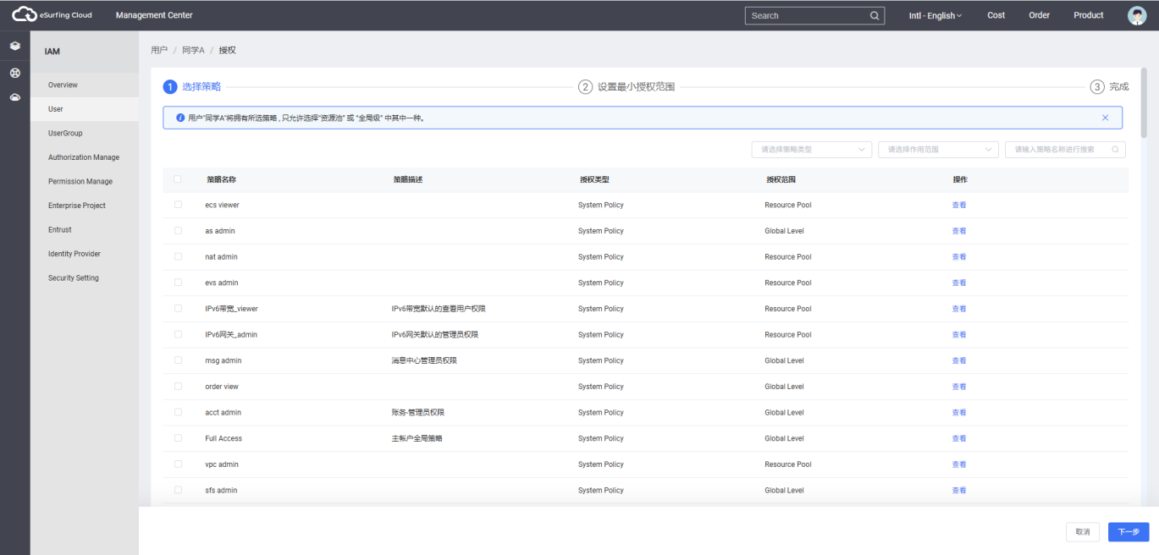
Description:
- If you have enabled Enterprise Management, you will not be able to create IAM projects. Please proceed with caution.
Step 4: On the Set the minimum authorization range page, select the enterprise project for which the IAM user is authorized.
Step 5: Click Confirm to complete the IAM user authorization.
After authorization is completed, the administrator can view or modify the IAM user's permissions on the page.

Viewing or Editing User Information
The administrator can view the user's basic information, associated user groups, and user logs. When personnel responsibilities change, the administrator can modify the user's permissions by adjusting their assigned user groups.
Viewing User Information
Step 1: The administrator logs in to the eSurfing Cloud official website using a registered eSurfing Cloud account.
Step 2: Click the account name in the upper-right corner, then select Personal Center from the dropdown menu.
Step 3: In the left navigation pane of the Personal Center, click IAM.
Step 4: In the left navigation pane of IAM, click User.
Step 5: In the user list, click View next to the corresponding user to check their detailed information.
Editing User Details and Status
Step 1: The administrator logs into the eSurfing Cloud official website using a registered eSurfing Cloud account.
Step 2: Click the account name in the upper-right corner, then select Personal Center from the dropdown menu.
Step 3: In the left navigation pane of Personal Center, click IAM.
Step 4: In the left navigation pane of IAM, click User.
Step 5: In the user list, click Edit next to the corresponding user to modify their information, including bound email address, mobile phone number, username, and description. To temporarily disable this IAM user, select the Close option in the user status field.
Step 6: Click Confirm to complete the user information and status modification.

Managing IAM User Access Keys
Access Keys (Access Key ID/Secret Access Key) are credentials used to authenticate your identity when accessing certain cloud services via development tools (APIs, SDKs). They cannot be used to log in to the console. The system identifies the user via the AK and verifies the request's signature using the SK. Through encrypted signature verification, the confidentiality and integrity of the request, as well as the authenticity of the requester, are ensured.
Description:
Currently, the cloud services that support access via AK/SK include Object Storage Service (OBS).
If an IAM user cannot log in to the console but needs to use access keys—or if their access keys are lost—an administrator can manage the IAM user's access keys in IAM.
The administrator can click on the user name in the IAM user list to enter the user details page, then select the Security Setting tab on the right to add or delete the user's access keys.
Description:
- The Security Setting feature provided by IAM allows administrators to manage the access keys of IAM users. Access keys can also be managed in My Credentials, which is available to all users who can log in to the console, enabling them to manage their own access keys.
- The access keys of the account and IAM users are separate identity credentials. This means that the account and IAM users can only use their own access keys for API calls.

- Adding and Downloading an Access Key
  - Click Create AccessKey.
  - If operation protection is enabled, the administrator must enter a verification code or password.
  - Click Confirm to generate and download the access key, then provide it to the user.
Description:
Each user can have a maximum of two access keys, which are permanently valid by default. Security Recommendation: To enhance account security, administrators should regularly rotate users' access keys
- Deleting an Access Key
  - Click Delete.
  - If operation protection is enabled, the administrator must enter a verification code or password.
  - Click Confirm.
- Enabling/Disabling an Access Key
The newly created access key is enabled by default. To disable it, follow these steps:
  - On the AccessKey tab, click Close next to the access key you want to deactivate.
  - If operation protection is enabled, you will need to enter a verification code or password. Then, click Confirm to disable the access key.
Enabling an access key follows a similar process to disabling. Please refer to the steps above.

User Groups and Authorizing Permissions

Creating a User Group and Authorizing Permissions
Administrators can create user groups, assign policies or roles to these groups, and then add users to the groups, thereby granting the users the corresponding permissions. IAM provides predefined common permissions for various services, such as administrator permissions and read-only permissions. Administrators can directly assign these system permissions to user groups. Once authorized, users can perform operations on cloud services based on their assigned permissions.
Creating a User Group
Step 1: The administrator logs in to the eSurfing Cloud official website using a registered eSurfing Cloud account.
Step 2: Click the account name in the upper-right corner, then select Personal Center from the dropdown menu.
Step 3: In the left navigation pane of Personal Center, click IAM.
Step 4: In the left navigation pane of IAM, click User Group.
Step 5: On the Manage User Group page, click Create User Group.
Step 6: Enter the User Group Name and Description, then click Confirm.
The newly created user group will be displayed in the user group list upon returning to the list page.

Authorizing Permissions to a User Group
The following steps apply only to adding permissions to a user group. If you need to remove permissions, refer to Removing User Group Permissions.
Step 1: The enterprise administrator logs in to the eSurfing Cloud official website using a registered eSurfing Cloud account.
Step 2: Click Console at the top of the homepage. On the Management Center page, under the Management and Deployment category, click IAM.
Step 3: On the IAM management page, select the UserGroup from the left-hand menu, then click Authorize next to the target user group to which permissions need to be added.
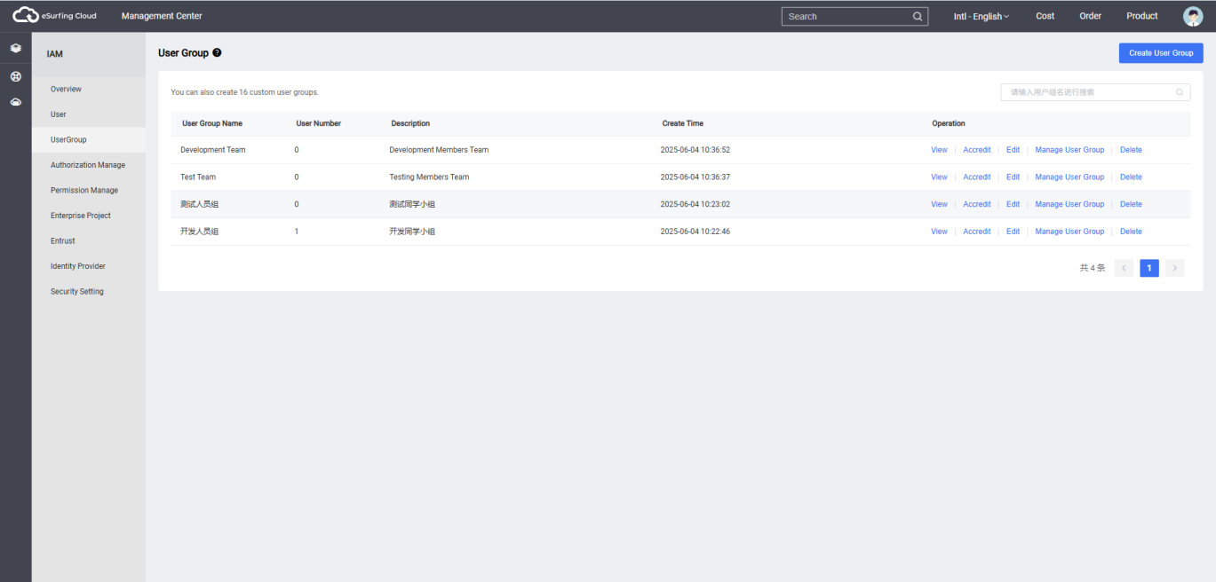
Step 4: On the User Group Select Policy page, check the permissions to be granted to the user group. Then, click Next.
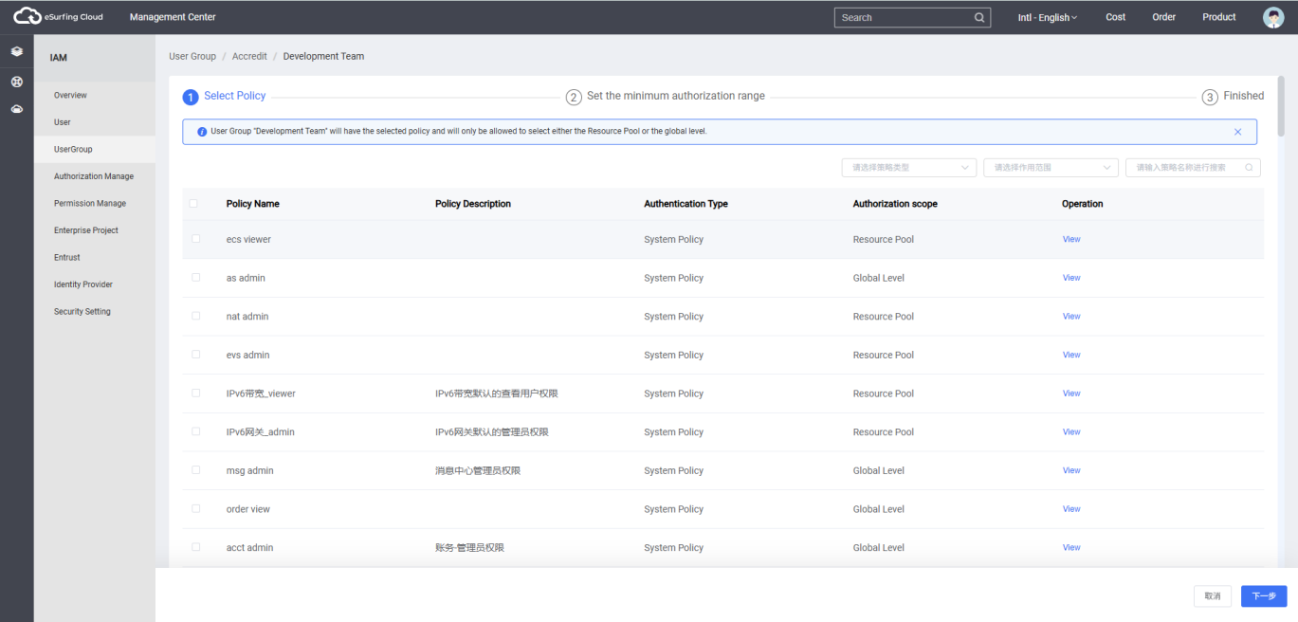
If the system policies fail to meet the authorization requirements, you can click Create Custom Policy in the upper-right corner of the permissions list to define a custom policy. Then, select the newly created policy to enable fine-grained permission management. Custom policies serve as an extension and supplement to system policies. For details, refer to Creating Custom Policies.
Step 5: Select the permission scope. The system will automatically recommend authorization scope options based on the selected policies, making it easier to choose an appropriate permission scope for users. The table below lists all available authorization scope schemes provided by IAM.
Table: Authorization Scope Scheme
Optional Solutions | Solution Specification
All Resources | IAM users can access resources across all regional projects and global services within the account based on the assigned permissions.
Designated Enterprise Project Resources | Select the specified enterprise project, and IAM users can utilize the resources within that enterprise project based on their permissions.  This option is available only after enabling enterprise projects.  If you have not yet enabled enterprise projects, authorization based on enterprise projects will not be supported.
Designated Regional Project Resources | Select the specified regional project, and IAM users can utilize the resources within that regional project based on their permissions.  If the scope of effect is set to Regional Project and the selected policies include global service permissions, the system will automatically set the scope of global service permissions to All Resources, while the scope of the selected regional project permissions will remain limited to the specified regional project.
Global Service Resources | IAM users can access global services based on their permissions. Global services are not bound to specific physical regions during deployment. When accessing global services (such as OBS), there is no need to switch regions.  If the scope of effect is set to Global Service and the selected policies include project-specific service permissions, the system will automatically expand the scope of project permissions to All Resources, while the scope of the selected global service permissions remains Global Service.
Step 6: Click Confirm to complete the user group authorization.

Adding Users to a User Group/Removing Users from a User Group
Enterprise administrators can create user groups, assign permissions, and add users to these groups, granting IAM users the corresponding group permissions for access control. By adding or removing IAM users from authorized user groups, permission changes can be quickly applied.
Procedure
Step 1: The administrator logs in to the eSurfing Cloud official website using a registered eSurfing Cloud account.
Step 2: Click the account name in the upper-right corner, then select Personal Center from the dropdown menu.
Step 3: In the left navigation pane of Personal Center, click IAM.
Step 4: In the left navigation pane of IAM, click User Group.
Step 5: On the User Group page, click Manage User Group next to the target user group.
Step 6: In the Manage User Group pop-up window, click Add or Remove for the target IAM user. After confirming the adjustments, click Confirm to complete the addition/removal of users in the user group.

Viewing/Editing/Deleting User Groups
Enterprise administrators can view user group details (including associated IAM sub-users), modify basic group information, and delete obsolete user groups when no longer needed.
Procedure
Step 1: Log in to the eSurfing Cloud official website using your registered administrator account.
Step 2: Click your account name in the top-right corner, then select Personal Center from the dropdown menu.
Step 3: In the left navigation pane of the Personal Center, click IAM.
Step 4: From the left navigation pane of the IAM, select User Group.
Step 5: On the User Group page:
Click View next to a user group to see detailed information
Click Edit to open the Edit User Group dialog box (update name/description)
Click Delete, and the prompt box for deleting user groups will appear. Enter the name of the user group to be deleted, and click Confirm to complete the deletion.

Removing User Group Permissions
Procedure
Step 1: The enterprise administrator logs in to the eSurfing Cloud portal using a registered eSurfing Cloud account.
Step 2: Click Console at the top of the homepage. On the Management Center page, under the Management and Deployment category, click IAM.
Step 3: On the IAM management page, click User Group in the left-hand menu, then click the name of the user group whose authorization is to be removed to enter the user group details page.
Step 4: Under the Authorization Record tab, click Revoke Authorization next to the permission that needs to be removed.
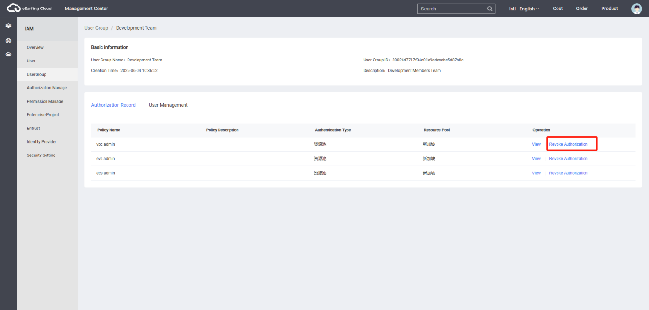
Step 5: In the pop-up window, click Confirm to remove the user group permissions.

Role-Based Authorization Method
Due to business interactions between services on the cloud platform, certain service roles depend on roles from other services to function properly. Therefore, when assigning role-based permissions, administrators must also grant the dependent roles for the authorization to take effect. Policies, however, have no dependency relationships and do not require additional dependent authorization.
Procedure
Step 1: The administrator logs in to the IAM console.
Step 2: In the user group list, click Authorize next to the newly created user group.
Step 3: On the authorization page, the administrator searches for the required role in the permission list's search box.
Step 4: When selecting a role, the system will automatically check its dependent roles.
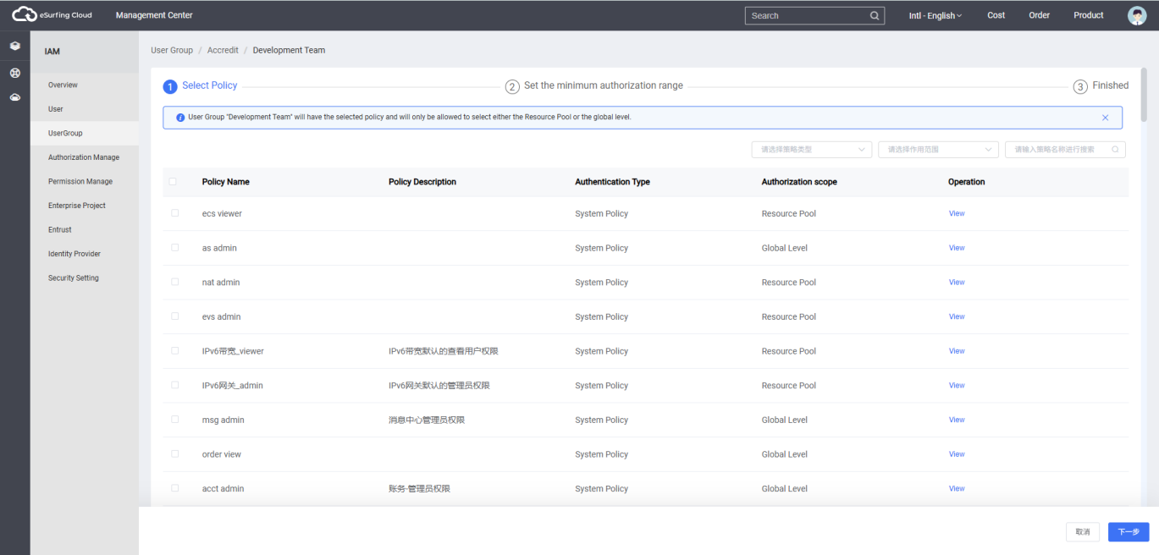
Step 5: Click below the selected permissions to check the role dependencies.
For example, the DAS Administrator role includes a Depends field in its definition, indicating dependency relationships.
When assigning the "DAS Administrator" role to a user group, the administrator must also grant the "Tenant Guest" role in the same project for the "DAS Administrator" permissions to take effect.
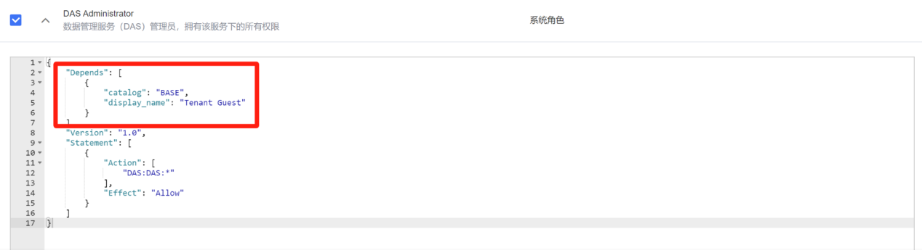
Step 6: Click Confirm to complete the authorization of dependent roles.

Permission Management

Basic Concepts of Permissions
Permission
By default, IAM sub-users created by administrators do not have any permissions. They need to be added to a user group, and the user group is granted policies or roles for the users within the group to obtain corresponding permissions. This process is called authorization. After authorization, users can operate cloud services based on the permissions granted.
Classification of Permissions
Permissions are categorized into roles and policies based on the granularity of authorization.
- Role: IAM initially provided a coarse-grained authorization mechanism that defined permissions based on users' job functions. This mechanism operated at the service level, offering a limited set of service-related roles for authorization. Due to the business dependencies between eSurfing Cloud services, granting a user a role might also require assigning additional dependent roles to properly complete business tasks. These roles cannot fully meet users' demands for fine-grained authorization, nor can they completely satisfy enterprises' security control requirements for the principle of least privilege.
- Policy: The latest IAM offering introduces a fine-grained authorization capability that can precisely control specific service operations, resources, and request conditions. Policy-based authorization is a more flexible approach, enabling enterprises to meet the principle of least privilege for security and access control. For example, in the ECS service, administrators can restrict IAM users to performing only a specified type of management operation on cloud server resources.
Policies are categorized into system policies and custom policies based on the entity that creates them.
Policy-System Policies
Cloud services come with preconfigured common authorization items in IAM, known as system policies. When administrators grant permissions to user groups, they can directly apply these system policies. System policies can only be used as-is and cannot be modified.
If an administrator cannot find the system policy for a specific service when granting permissions to a user group or delegation on the IAM Console, it is because that service currently does not support IAM.
Policy-Custom Policy
If system policies cannot meet the authorization requirements, administrators can create custom policies based on the supported authorization items of each service and grant these policies to user groups for fine-grained access control. Custom policies serve as an extension and supplement to system policies. Currently, IAM supports two configuration methods for custom policies: visual editor and JSON view.

Role
Roles represent the initial coarse-grained authorization mechanism provided by IAM, defining permissions based on users' job functions. This mechanism operates at the service level, offering a limited set of service-related roles for authorization.
Due to business dependencies between eSurfing Cloud services, when assigning a role to a user group, any dependent roles must also be granted to ensure proper permission enforcement. For details, refer to User Groups & Authorization > Authorization Method for Dependent Roles.
Role Content
When selecting a role for a user group, click the icon in front of the role to view its details. Taking the DAS Administrator as an example, the content of role-based permissions is explained.
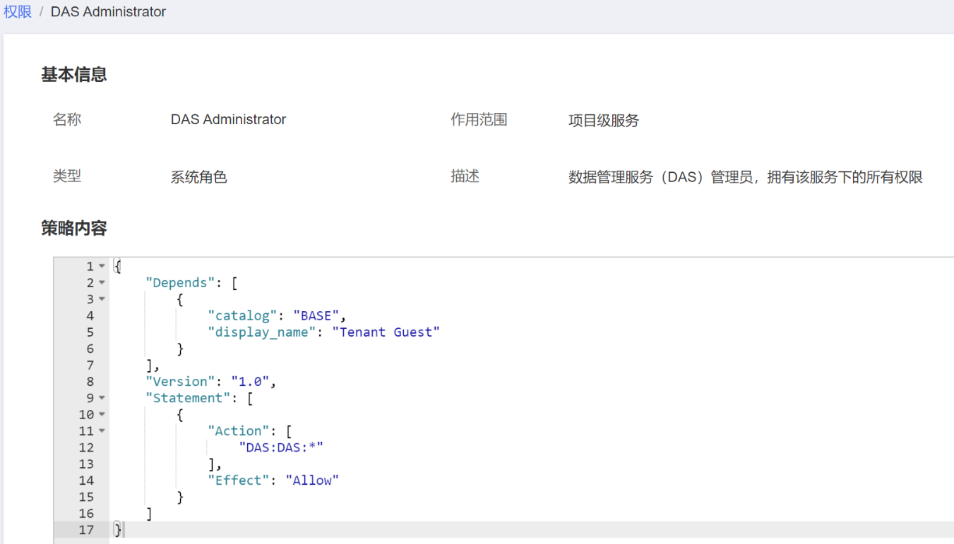
Parameter Description
Table Parameter Description
Parameters |  | Definition | Value
Version |  | Role Version | 1.0: Role-Based Access Control.  1.1: Policy-Based Access Control.
Statement:  Role Authorization Statement | Action: Authorization Item | Operation Permissions | The format is: Service name: Resource type: Operation  "DAS:DAS:*": Indicates all operations on the DAS resource type in the DAS service.  "DAS" is the service name.  "DAS" is the resource type.  "" is a wildcard, representing all possible operations on the DAS resource type.
Statement:  Role Authorization Statement | Effect: | Determine whether the operation permissions in the Action are allowed to be executed. | - Allow  - Deny  Description  When the same Action has both Allow and Deny in its Effect, the Deny rule takes precedence.
Depends:  Role dependencies | catalog | Service of the dependent role | Service name. For example, BASE, VPC.
Depends:  Role dependencies | display_name | Dependent role name | Role Name  Description  When granting the example role "DAS Administrator" to a user group, you must also select its dependent roles—"Tenant Guest" and "DNS Administrator"—for it to take effect.

Policy

Policy Content
When selecting a policy for a user group, click the option before the policy to view its detailed content. Take the system policy "IAM ReadOnlyAccess" as an example.
{
"Version": "1.1",
"Statement": [
{ "Action": [
"iam:*:get*",
"iam:*:list*",
"iam:*:check*" ],
"Effect": "Allow"
}
]
}

Policy Grammar
Take the custom policy of OBS as an example to illustrate the syntax of the policy.
{
"Version": "1.1",
"Statement": [
{
"Effect": "Allow",
"Action": [
"obs:bucket:ListAllMyBuckets",
"obs:bucket:HeadBucket",
"obs:bucket:ListBucket",
"obs:bucket:GetBucketLocation"
],
"Condition": {
"StringEndWithIfExists": {
"g:UserName": [
"specialCharactor"
]
},
"Bool": {
"g:MFAPresent": [
"true"
]
}
},
"Resource": [
"obs:*:*:bucket:*"
]
}
]
}
Policy Structure
The policy structure consists of two parts: Version (policy version number) and Statement (policy permission statements). The Statement section can include multiple entries, each representing a distinct authorization rule.
Figure: Policy Structure
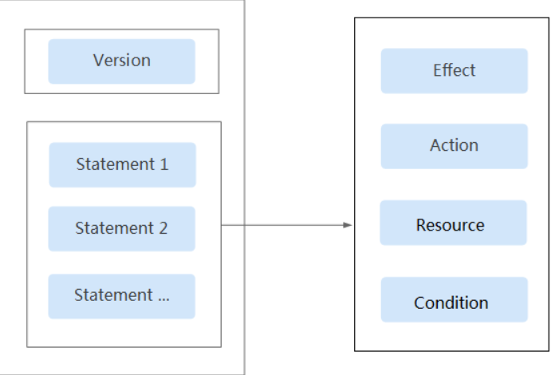
Policy Parameters
The policy parameters consist of two parts: Version and Statement. Below is a detailed explanation of the policy parameters. Once you understand the policy parameters, you can customize the policy according to your scenario.
Table: Policy Parameter Description
Parameters |  | Definition | Value
Version |  | Policy Version | 1.0: Role-Based Access Control.  1.1: Policy-Based Access Control.
Statement:  Policy authorization statement | Effect: | Define whether the operation permissions in the Action are allowed to be executed. | - Allow  - Deny  Description:  When the same Action has both 'Allow' and 'Deny' in its Effect, the 'Deny' principle takes precedence.
Statement:  Policy authorization statement | Action: Authorization Item | Operation Permissions | Format as 'service name:resource type:operation'.  The permission entry supports the wildcard symbol *, denoting 'all'.  Example:  "obs:bucket:ListAllMybuckets": Indicates the permission to view the OBS bucket list, where 'obs' is the service name, 'bucket' is the resource type, and 'ListAllMyBuckets' is the operation.  You can check all authorization items for the service in the corresponding service's API documentation.
Statement:  Policy authorization statement | Condition: | The specific conditions that enforce the policy, including condition keys and operators. | Condition operator: {Condition key: [Condition value1, Condition value2]}  If you set multiple conditions, the policy will only take effect when all conditions are met.  Example:  "StringEndWithIfExists":{"g:UserName":["specialCharactor"]}: The statement takes effect when the username entered by the user ends with "specialCharactor".
Statement:  Policy authorization statement | Resource:  Type | Resources affected by the policy. | Format as "service name:region:domainId:resource type:resource path". The resource type supports wildcard *, which represents all.  Example:  - "obs:::bucket:": represent all OBS buckets.  - "obs:::object:my-bucket/my-object/*": represent all objects under the my-object directory in the my-bucket bucket.
- A condition key represents the key value within the Condition element of a policy statement. Based on its scope of application, it is categorized into global condition keys and service-specific condition keys.
  - Global condition keys (prefixed with g:) apply to all actions, and IAM provides universal global condition keys.
    - Universal Global Condition Keys: During the authorization process, cloud services do not need to provide user identity information—IAM automatically retrieves and authenticates it. For details, see Table: Universal Global Condition Keys.
  - Service-specific condition keys (prefixed with the service abbreviation, e.g., obs:) are only applicable to operations of the corresponding service. For details, refer to the user guide of the respective cloud service.
Table: Universal Global Condition Keys
Global Condition Key | Type | Description
g:CurrentTime | Time | The time when the authentication request was received. Expressed in ISO 8601 format, for example:2012-11-11T23:59:59Z
g:DomainName | String | Account Name
g:MFAPresent | Bool | Whether to use MFA (Multi-Factor Authentication) to obtain the token
g:MFAAge | Numerical Value | Validity duration of tokens obtained through MFA (Multi-Factor Authentication). This condition is used together with g:MFAPresent.
g:ProjectName | String | Project Name
g:ServiceName | String | Service Name
g:UserId | String | IAM User ID
g:UserName | String | IAM User Name

- Operator
An operator, a condition key, and a condition value together constitute a complete condition statement. A policy takes effect only when its request conditions are met. For details, refer to the table below. The operator suffix IfExists indicates that a policy takes effect if a request value is empty or meets the specified condition. For example, if the operator StringEqualsIfExists is selected for a policy, the policy takes effect if a request value is empty or equal to the specified value.
Operators (Operators are string operators. They are not case-sensitive unless otherwise specified.)
Operator | Type | Description
StringEquals | String | The request value is the same as the condition value (case-sensitive).
StringNotEquals | String | The request value is different from the condition value (case-sensitive).
StringEqualsIgnoreCase | String | The request value is the same as the condition value.
StringNotEqualsIgnoreCase | String | The request value is different from the condition value.
StringLike | String | The request value contains the condition value.
StringNotLike | String | The request value does not contain the condition value.
StringStartWith | String | The request value starts with the condition value.
StringEndWith | String | The request value ends with the condition value.
StringNotStartWith | String | The request value does not start with the condition value.
StringNotEndWith | String | The request value does not end with the condition value.
StringEqualsAnyOf | String | The request value is the same as any of the configurable condition values (case-sensitive).
StringNotEqualsAnyOf | String | Multiple condition values can be configured, and the request value differs from all condition values (case-sensitive).
StringEqualsIgnoreCaseAnyOf | String | Multiple condition values can be configured, and the request value will match if it is equal to any of the condition values.
StringNotEqualsIgnoreCaseAnyOf | String | Multiple condition values can be configured, and the request value differs from all of them.
StringLikeAnyOf | String | Multiple condition values can be configured. The request value contains any of the condition values.
StringNotLikeAnyOf | String | Multiple condition values can be configured. The request value does not contain any of the condition values.
StringStartWithAnyOf | String | Multiple condition values can be configured. The request value starts with any of the condition values.
StringEndWithAnyOf | String | Multiple condition values can be configured. The request value ends with any of the condition values.
StringNotStartWithAnyOf | String | Multiple condition values can be configured. The request value does not start with any of the condition values.
StringNotEndWithAnyOf | String | Configurable with multiple condition values, the request value does not end with any of the specified condition values.
NumberEquals | Numerical Value | The request value is equal to the condition value.
NumberNotEquals | Numerical Value | The request value is not equal to the condition value.
NumberLessThan | Numerical Value | The request value is less than the condition value.
NumberLessThanEquals | Numerical Value | The request value is less than or equal to the condition value.
NumberGreaterThan | Numerical Value | The request value is greater than the condition value.
NumberGreaterThanEquals | Numerical Value | The request value is greater than or equal to the condition value.
NumberEqualsAnyOf | Numerical Value | Multiple condition values can be configured. The request value must match any of them.
NumberNotEqualsAnyOf | Numerical Value | Multiple condition values can be configured. The request value must differ from all of them.
DateLessThan | Time | The request value is earlier than the condition value.
DateLessThanEquals | Time | The request value is earlier than or equal to the condition value.
DateGreaterThan | Time | The request value is later than the condition value.
DateGreaterThanEquals | Time | The request value is later than or equal to the condition value.
Bool | Bool | The request value is equal to the condition value.
IpAddress | IP address | The request value is within the IP address range set in the condition value.
NotIpAddress | IP address | The request value must not fall within any IP address range set in the condition value(s).
IsNullOrEmpty | Null | The request value is null or an empty string.
IsNull | Null | The request value is null.
IsNotNull | Null | The request value is not null.

Policy Authentication
When a user initiates an access request, the system performs an authorization check based on the actions defined in the access policies granted to the user. The authorization rules are as follows:
Figure: System Authorization Logic Diagram
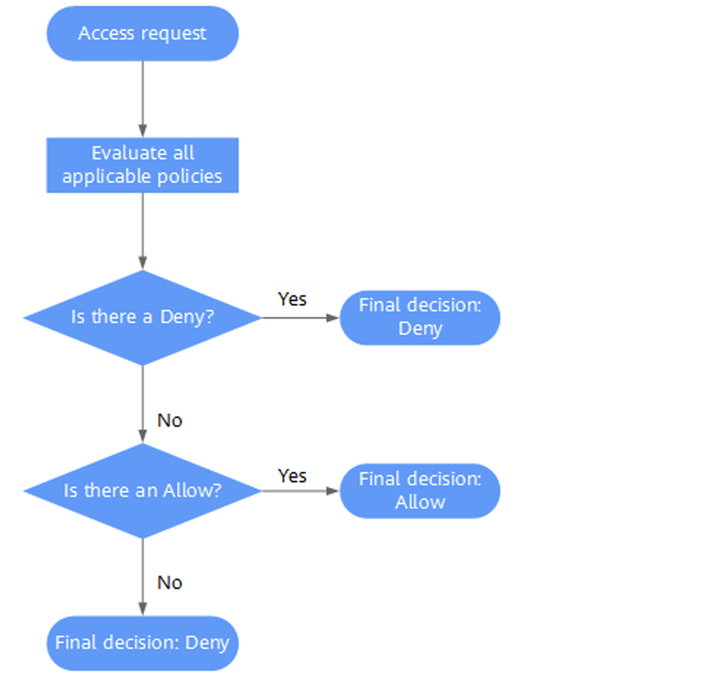

- A user initiates an access request.
- The system looks for a Deny among the applicable actions of the policies from which the user gets permissions. If the system finds an applicable Deny, it returns a decision of Deny.
- If no Deny is found applicable, the system looks for an Allow that would apply to the request. If the system finds an applicable Allow, it returns a decision of Allow.
- If no Allow is found applicable, the system returns a decision of Deny, and the authentication ends.

Viewing Authorization Records
If you need to view all authorization relationships under the current account, you can go to the IAM > Authorization Management page. IAM Permission Management displays all authorization relationships in your account, allowing you to filter and view specific authorizations using criteria such as Policy Name, User Name/User Group Name/Trust Name, Project Region, Enterprise Project (if enabled), and Subject Type.
- If you have activated and are using enterprise projects, you can choose between the IAM Project View and Enterprise Project View to view the authorization relationships for IAM projects and enterprise projects, respectively.
- If you have not yet activated enterprise projects, the IAM project view will be displayed by default.
IAM Project View
In the IAM Project View, you can filter authorization records by the following conditions.
- Policy Name: The name of the policy. Click the policy name to view policy details.
To view authorization records for a specific permission, select Policy Name as the filter condition, enter the target permission name, and check the authorization records for that permission.
- Username/User Group Name/Trust Name: The name of an IAM user, user group, or delegation.
To view the IAM project authorization records for a specific IAM user/user group/trust, select Username, User Group Name, or Delegation Name as the filter condition, enter the corresponding name, and check its authorization records.
Description:
Based on IAM project authorization, the minimum authorization unit is the user group. When viewing the authorization records of a specified IAM user under the IAM project view, the authorization records of the user group to which the IAM user belongs will be displayed.
- Project Region: IAM project or region name, which defines the scope of permissions. To view IAM project authorization details, please select:
  - Global Services: View all global service authorization records.
  - All Projects: View authorization records based on All Projects permissions. When authorized for All Projects, the permissions apply to all projects, including global services and all existing or future projects.
  - Specified Project: View authorization records based on default region and sub-project permissions.
- Subject Type: The authorized object type can be selected from three options: User, User Group, or Delegation. In the IAM project view, the principal type can be chosen as User Group or Delegation. If the User is selected, the filtering result will be empty.
- Enterprise Project: Name of the enterprise project. If you are in the IAM user view and select Enterprise Project as the filter condition, then enter the enterprise project name, the system will automatically switch to the enterprise project view.
Enterprise Project View
In the Enterprise Project View, you can select the following filter conditions to view corresponding authorization records.
- Policy Name: Permission Name. Click the permission name to view permission details.
To view the authorization records for a specific permission, select Policy Name as the filter condition, enter the name of the specified permission, and check the authorization records for that permission.
- Username/User Group Name/Delegation Name: IAM User, User Group, Delegation Name.
To view the enterprise project authorization records for a specified IAM user/user group, select User Name or User Group Name as the filter condition, enter the corresponding name, and check its authorization records.
Description:
- The enterprise project does not support the delegation feature. Please select either User Name or User Group Name as the filter condition.
- For enterprise project-based authorization where the minimum authorization unit is a user, when viewing the authorization records of a specified IAM user under the enterprise project view, the system displays both the IAM user's authorization records and those of their affiliated user groups.
- Enterprise project: The name of the enterprise project, which defines the scope of the permission. To view the authorization records for a specified enterprise project, select the region filter as Enterprise Project, enter the enterprise project name, and view all authorization records based on that enterprise project.
- Principal type: The type of objects that are authorized. There are three principal types: User, User Group, and Agency. In the Enterprise Project view, you can choose the principal type as User or User Group. If Agency is selected, no results will be displayed.
- Project region: IAM project or region. If you are in the enterprise project view and select Project Region as the filter condition, then choose a specific project, the system will automatically switch to the IAM project view.

Custom Policies

Creating a Custom Policy
When system policies cannot meet authorization requirements, administrators can create custom policies and grant them to user groups for fine-grained access control. Custom policies serve as extensions and supplements to system policies.
Currently, IAM supports the following two methods for creating custom policies:
l Visual Editor: Create custom policies through the visualization view without needing to understand JSON syntax. Simply navigate the visualization view's toolbar to select policy components such as cloud services, actions, resources, and conditions, and the policy will be automatically generated.
l JSON View: Through the JSON view, you can create custom policies by selecting a policy template and then editing the policy content according to specific requirements; alternatively, you can directly write the policy content in JSON format within the editing box.
Configuring Custom Policies via the Visual Editor
Step 1: Log in to the IAM console.
Step 2: Under IAM, navigate to the left-side panel, select the IAM > Policy Management tab, and click Create Custom Policy in the upper-right corner.
Step 3: Enter a policy name.
Step 4: Select Visual View for Set policy content.
Step 5: Set the policy in the Policy content section.
1.Select allow or refuse.
2.Select Cloud services.
Description:
l Only one cloud service can be selected here. To configure a custom policy for multiple cloud services, click add permission after completing this configuration to create authorization statements for multiple services. Alternatively, use the JSON view to configure a custom policy.

l Currently, a single custom policy cannot include both global and project-specific cloud services. To configure custom policies for both global and project-specific services, please create two separate custom policies. This approach facilitates setting the minimum required authorization scope during permission assignment.

3.Select Operation, then check the product permissions as needed.
4.(Optional) Select the resource type. If you choose Specific resources, you can click Specify through the resource path to specify the resource to be authorized.
Description:
Currently, cloud services that support authorization for specific resources only include OBS and Distributed Message Service (DMS).

Table: Resource Types
Type | Description
Specific Resource | Grant the IAM user corresponding permissions to specific resources. For example, to grant permissions for buckets with names starting with 'TestBucket', configure the bucket by specifying the resource path and add the following resource path: OBS:::bucket:TestBucket*.  Description  Specify bucket resources: [Format] OBS:::bucket:BucketName  For bucket resources, IAM automatically generates the resource path prefix "obs:::bucket:". Specify the exact resource path using the bucket name, with wildcard * supported.  For example: obs:::bucket: indicates any OBS bucket. To specify an object resource: [Format] OBS:::object: bucket-name/object-name.  For object resources, IAM automatically generates the resource path prefix "obs:::object"**:. The specific resource path is specified by bucket name/object name, and wildcards are supported.  For example: obs:::object:my-bucket/my-object/* indicates any object in the my-object directory of the my-bucket bucket.
All Resources | Grant the IAM user corresponding permissions to all resources.

5.(Optional) Add conditions: Click Add conditions, select a Condition key, choose an operator, and enter the corresponding value based on the operator type.
Table: Condition Parameters
Name | Description
Condition Key | A key in the Condition element of a statement. There are global condition keys and service-specific condition keys. Global condition keys (prefixed with g:) are available for operations of all services, whereas service-specific condition keys (prefixed with a service abbreviation, such as obs:) are available only for the corresponding service. For details, see the user guide of the respective cloud service.
Operator | Used together with a condition key and condition value to form a complete condition statement.
Value | Used together with a condition key and an operator that requires a keyword to form a complete condition statement.
Table: Global Request Conditions
Global Condition Key | Type | Description
g:CurrentTime | Time | The time when an authorization request is received. The time is in ISO 8601 format, for example: 2012-11-11T23:59:59Z.
g:DomainName | String | Account Name
g:MFAPresent | Bool | Whether to obtain a token through MFA authentication.
g:MFAAge | Numerical Value | Validity period of a token obtained. This condition must be used together with g:MFAPresent.
g:ProjectName | String | Project name
g:ServiceName | String | Service name
g:UserId | String | IAM user ID
g:UserName | String | IAM user name

Step 6: (Optional) Under Policy Configuration Method, select the JSON view to convert the policy content configured in the Visual View into JSON statements. You can modify the policy content in the JSON view.
Description:
If the modified JSON statement contains syntax errors, the policy cannot be created. You can manually review and correct the content or click Reset in the pop-up window to restore the JSON file to its unmodified state.
Step 7: (Optional) To create multiple custom policies, click Add Permission, or click the plus (+) icon on the far right of an existing policy to clone its permissions.
Step 8: Enter a policy description (optional).
Step 9: Click Confirm to complete the creation of the custom policy.
Step 10: Assign the newly created custom policy to a user group, granting the permissions defined in the policy to all users within the group.
Description:
The process of granting a custom policy to a user group is the same as assigning a system policy. For details, see "User Groups and Permissions".
Configuring a Custom Policy in JSON View
Step 1: Log in to the IAM console.
Step 2: Under IAM, select the IAM > Policy Management tab from the left navigation pane, then click Create Custom Policy in the upper-right corner.
Step 3: Enter a policy name.
Step 4: Under Set policy content, select JSON View.
Step 5: (Optional) In the Policy content section, click Copy from existing strategy (e.g., select EVS FullAccess as a template).
Description:
Here, you can select policies for multiple services simultaneously. However, these policies must have the same scope of effect—meaning they must all be either global services or project-specific services. If you need to configure custom policies for both global and project-specific services at the same time, please create two separate custom policies to facilitate setting the minimum authorization scope during permission assignment.
Step 6: Click Confirm.
Step 7: Modify the policy statement in the template:
l Effect: Specify Allow or Deny.
l Action: Enter the API permission items (e.g., "evs:volumes:create") from the Permissions list of each service (as shown) to implement fine-grained authorization.
Description:
The version number (Version) of a custom policy is fixed as 1.1 and cannot be modified.
Step 8: (Optional) Enter a policy description.
Step 9: After clicking Confirm, the system will automatically validate the syntax. If the page redirects to the policy list, the custom policy has been successfully created. If a Policy Syntax Error prompt appears, please revise the content according to syntax specifications.
Step 10: Assign the newly created custom policy to a user group to grant the permissions defined in the policy to all users within that group.
Description:
Assigning custom policies to user groups follows the same procedure as assigning system policies. For details, refer to Creating User Groups and Assigning Permissions.

Modifying and Deleting a Custom Policy
Modifying a Custom Policy
Modify Custom Policy Name, Description, and Content
1. In the left navigation pane on the IAM console, choose Policy Management the tab.
2. Click Edit in the Operation column of the target policy, or click the policy name to access its details page.
3. Modify the policy name and policy description as needed.
4. Adjust the policy configuration using the visual editor method.
5. Click Confirm to save changes.
Deleting a Custom Policy
Description:
If the current custom policy has been assigned to a user group or delegation, it cannot be deleted. The custom policy can only be deleted after it is removed from the user group or delegation.
1.In the left navigation pane of the IAM console, the administrator selects Policy Management.
2.In the Operation column of the specified policy, click Delete.
3.Click Confirm to confirm the deletion.

Custom Policy Usage Examples
Using a Custom Policy Along with Full-Permission System-Defined Policies
If you grant an IAM user a high-permission system policy, such as "FullAccess", but do not want the IAM user to have permissions for a certain service, such as Cloud Trace Service (CTS), you can create a custom policy. Set the Effect of the custom policy to Deny, then assign both the high-permission system policy and the custom policy to the user. As an explicit deny in any policy overrides any allows, the authorized IAM user will be able to perform all operations on all other services except CTS.
The following policy example indicates: Deny the IAM user access to CTS.
{
"Version": "1.1",
"Statement": [
{
"Effect": "Deny" ，
"Action": [
"cts:*:*"
]
}
]
}
Description:
- Action is the authorization item, formatted as: service name:resource type:operation. "cts:*:*" indicates all operations for CTS. Here, "cts" is the service name; "*" is a wildcard, representing all operations that can be performed on all resource types.
- Effect means to take effect, where Deny means to deny, and Allow means to allow.
Using a Custom Policy Along with a System-Defined Policy
- If you grant an IAM user a system policy for a single service, such as BMS FullAccess, but do not want the user to have the permission to create DPSs (bms:servers:create) included in BMS FullAccess, you can create a custom policy with the same Action and set its Effect to Deny. Then, assign both the system policy (BMS FullAccess) and the custom policy to the user. As an explicit deny in any policy overrides any allows, the user will be able to perform all BMS operations except creating DPSs.
The following policy example indicates: deny IAM users from creating DPSs.
{
"Version": "1.1",
"Statement": [
{
"Effect": "Deny" ，
"Action": [
"bms:servers:create"
]
}
]
}
- If you grant an IAM user the "OBS ReadOnlyAccess" permission but want to restrict certain users (e.g., those with usernames starting with "TestUser") from accessing specific OBS resources (such as buckets with names beginning with "TestBucket"), you can create a custom policy targeting those resources and set its Effect to Deny. Then, assign both the OBS ReadOnlyAccess policy and the custom policy to the user. As an explicit deny in any policy overrides any allows, the user will retain read-only access to all OBS buckets except those starting with "TestBucket".
The following policy example indicates: deny users whose names begin with TestUser access to buckets whose names begin with TestBucket.
{
"Version": "1.1",
"Statement": [
{
"Effect": "Deny" ，
"Action": [
"obs:bucket:ListAllMybuckets",
"obs:bucket:HeadBucket",
"obs:bucket:ListBucket",
"obs:bucket:GetBucketLocation"
],
"Resource": [
"obs:*:*:bucket:TestBucket*"
],
"Condition": {
"StringStartWith": {
"g:UserName": [
"TestUser"
]
}
}
}
]
}
Description:
Currently, only some services support resource-level authorization, such as OBS.
For services that do not support resource-level authorization, if a custom policy includes a resource type, the policy cannot be created successfully.
Using Only a Custom Policy
You can only create a custom policy without using system policies to achieve IAM user-specified authorization.
- The following policy example indicates: Only allow IAM users to use ECS, EVS, VPC, ELB, and AOM.
{
"Version": "1.1",
"Statement": [
{
"Effect": "Allow" ，
"Action": [
"ecs:*:*",
"evs:*:*",
"vpc:*:*",
"elb:*:*",
"aom:*:*"
]
}
]
}
- The following policy example indicates: Allow specific IAM users (with usernames starting with "TestUser") to delete specific OBS objects (all objects under the "my-object" directory in the "my-bucket" bucket).
{
"Version": "1.1",
"Statement": [
{
"Effect": "Allow" ，
"Action": [
"obs:object:DeleteObject"
],
"Resource": [
"obs:*:*:object:my-bucket/my-object/*"
],
"Condition": {
"StringStartWith": {
"g:UserName": [
"TestUser"
]
}
}
}
]
}
- The following policy example indicates: Allow IAM users to access all services except ECS, EVS, VPC, ELB, and AOM.
{
"Version": "1.1",
"Statement": [
{
"Effect": "Allow" ，
"Action": [
"*:*:*"
]
} ,
{
"Action": [
"ecs:*:*",
"evs:*:*",
"vpc:*:*",
"elb:*:*",
"aom:*:*",
],
"Effect": "Deny"
}
]
}

Project
Each region is associated with a default project, which is pre-configured by the system to isolate resources (compute, storage, and network resources) across different physical regions. When authorizing access at the regional default project level, IAM users gain access to all resources within that region in your account.
- Granting User Group Permissions for a Project
You can assign permissions based on projects to control access to resources in specific projects.
Step 1: In the user group list, click Accredit next to the target user group to access the authorization page.
Step 2: On the Accredit page, select the region-level project permissions to be granted to the user group, then click Next.
Step 3: Define the permission scope. If Resource Pool is selected, you must also specify the target project(s) for authorization.
Step 4: Click Confirm to complete the authorization process.
Description:
For more details about user group authorization, see Creating a User Group and Granting Permissions.
Switching Project or Region
After logging in, you must first switch the region or project to access and use the authorized cloud services; otherwise, the system will prompt that you have no permissions. The global region services do not require switching.
Step1: Log in to the console.
Step2: Navigate to the specific cloud service page. If the cloud service is project-specific, click the region drop-down box at the top of the page to switch regions.

Delegation

Delegating Resource Management to Another Account

Basic Workflow
Through the delegation trust feature, you can delegate your operational permissions to more professional and efficient accounts or cloud services. These accounts or cloud services can then perform daily resource management tasks on your behalf based on the assigned permissions.
Note:
Only the primary account of eSurfing Cloud can be delegated; IAM sub-users cannot be delegated.
Taking Account A's delegation of Account B to manage certain resources within Account A as an example, the principle and method of delegation are explained. Account A is the delegating party, and Account B is the delegated party.
Step 1: Account A creates a delegation.
Figure: Delegating party creates a delegation.
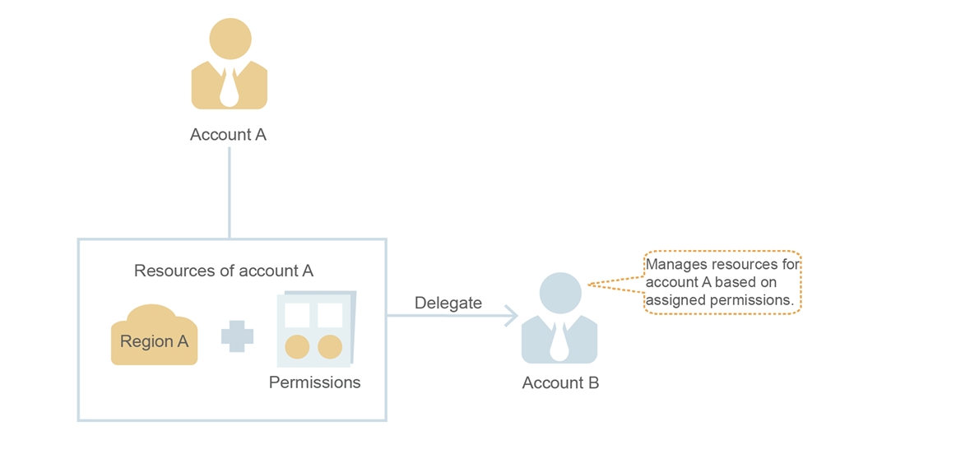

Step 2: (Optional) Account B assigns delegation permissions.
- Create a user group (e.g., Agency) and grant the user group a permission policy for managing delegations.
- Create a user and add the user (Job) to the user group (Agency).
Figure: Grant Delegated Permissions to the Delegated Party

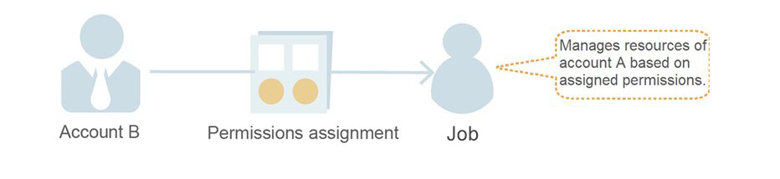

Step 3: Account B or its IAM users manage the delegated resources according to the assigned permissions.
- The delegated party logs in to their own account and switches roles to Account A.
- Switches to the authorized region and manages Account A's resources according to the assigned permissions.
Figure: Delegated Party Performs Role Switching
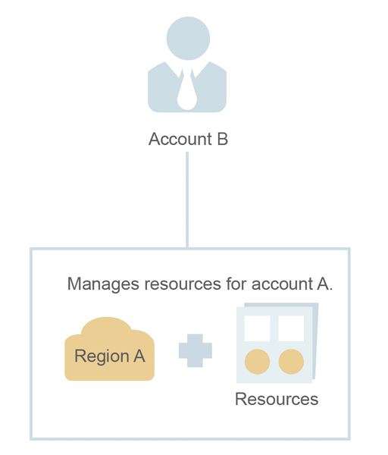

Creating a Delegation (Delegating Party's Operations)
By creating a delegation, you can share resources with other accounts or delegate the management of resources to more specialized individuals or teams. After logging in with their own account, the delegated party can switch to the delegating party's account to manage the delegated resources. This avoids the need for the delegating party to share their security credentials (passwords/keys) with others, ensuring account security.
Procedure
Step 1: The delegating party logs in to the eSurfing Cloud official website using a registered eSurfing Cloud account.
Step 2: Click Console at the top of the homepage. On the Management Center page, under the Management and Deployment category, click IAM.
Step 3: On the IAM management page, select Delegate from the left-hand menu.
Step 4: On the Delegate page, click ＋Create Delegation.
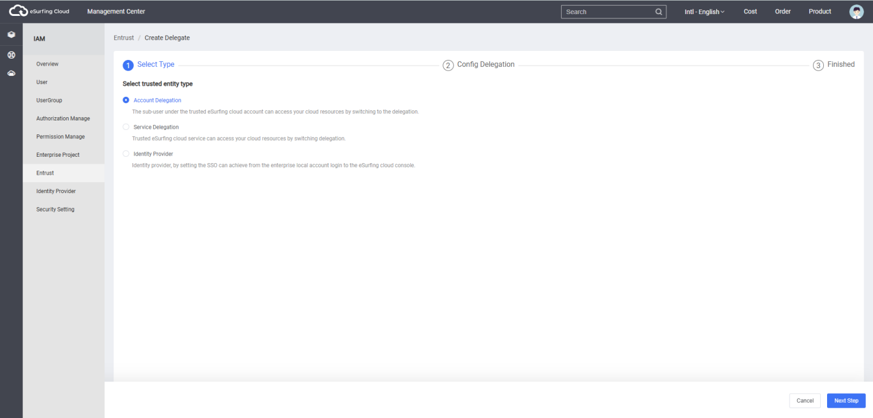
Step 5: On the Create Delegation page, enter a Delegation Name, select Standard Account as the Delegation Type, and input the Account Name of the other account with which you want to establish a delegation relationship in the Delegated Account field.
Description:
- Regular Account: Share resources with other accounts or delegate the management of resources in the account to more specialized individuals or teams. The delegated account is an account and cannot be an IAM username.
- Cloud Service: Authorize designated cloud services to use other cloud services. For details, see Delegating Other Cloud Services to Manage Resources.
Step 6: Set the Duration and Description information.
Step 7: Click Next to proceed to the Delegated authorization page.
Step 8: Check the permissions to be granted to the delegation, then click Next to select the scope of the permissions.
Description:
- Granting delegation authorization means authorizing another account, while granting user group authorization means authorizing IAM users within an account. The two methods operate the same way, differing only in the number of selectable permissions. For the authorization procedure, see Granting Authorization to User Groups.
- To ensure the security of your account, the Security Administrator permission cannot be assigned to a delegation. It is recommended to follow the principle of least privilege and grant only the minimum necessary permissions based on your business scenario.
Step 9: Click Confirm to complete the delegation setup.
Description:
The delegating party has completed the setup. After providing the delegated party with the delegating party's account name, delegation name, delegation ID, and delegated resource permissions, the delegated party can switch roles to the delegating party's account to manage the delegated resources.

Assigning Delegation Permissions (Delegated Party's Operations)
When another account establishes a delegation relationship with you (i.e., you are the delegated party), only high-permission users (the account itself and members of the admin user group) can manage the delegated resources by default. If you require assistance from regular IAM users to manage the delegation, you can grant delegation management permissions to IAM sub-users.
If you have multiple delegation relationships, you may assign broad delegation permissions to IAM users (allowing them to manage all delegations) or grant fine-grained permissions, restricting them to managing only specified delegations. In this case, when an IAM user switches roles, they can only assume the authorized delegation(s) and cannot access others. You can create fine-grained delegation permissions to authorize IAM users to manage only designated delegations.
Prerequisites
- An existing eSurfing Cloud account has established a delegation relationship with you.
- You have obtained the delegating party's account name, delegation name, and delegation ID.
Procedure
Step 1: Create a user group and assign permissions.
- The delegated party logs in to the eSurfing Cloud official website using their eSurfing Cloud account.
- Click Console at the top of the homepage, then navigate to Management and Deployment in the Management Center and select IAM.
- In the left navigation pane of IAM, click User Group.
- On the User Group page, click Create User Group, then click Create User Group again on the redirected page.
- In the pop-up window, enter the User Group Name and Description.
- Click Confirm to return to the User Group list page in IAM. The newly created user group will be displayed in the list.
- Click Authorize next to the newly created user group.
- Create a custom policy.
Description:
To grant IAM users fine-grained delegation permissions (restricting them to managing only specified delegations), follow these steps to create fine-grained delegation permissions. If fine-grained delegation authorization is not required and you want to grant IAM users permissions to manage all delegations, skip this step and proceed directly to the next step.
- On the Select Policy page, click Create Custom Policy in the upper-right corner of the permissions list.
- Enter a policy name.
- Select JSON View for Policy content.
d. In the Policy content area, enter the following content:
{
"Version": "1.1",
"Statement": [
{
"Action": [
"iam:tokens:assume"
]，
"Resource": {
"uri": [
"/iam/agencies/agencyTest"
]
}，
"Effect": "Allow"
}
]
}
Description:
- Replace agencyTest with the authorized delegation name, which is obtained from a delegating party in advance. Copy the other content without making any changes.
- This document briefly explains the necessary steps to quickly complete fine-grained delegation authorization. For more details on permissions, see the Permission Management section.
e. Click Next to proceed with authorization.
9. Select the custom policy created in the previous step or the Agent Operator permission, and click Next. Custom policy: Users can only manage delegations with specified IDs and cannot manage other delegations. Agent Operator permission: Users can manage all delegations.
10. Select the authorization scope solution.
11. Click Confirm, and the user group authorization is completed.
Step 2: Create an IAM user and add it to a user group.
- In the left navigation pane of the IAM, click User.
- On the User page, click Create User. Then, click Create Sub-User on the redirected page.
- In the Create Sub-User dialog box, enter basic user information such as Email Address, Username, and Mobile Number.
- In the User Group dropdown menu, select the user group created in Step 1.
- Click Create to complete the IAM sub-user creation.
Description:
After the delegation permission assignment is complete, the newly created IAM user can switch roles to the delegating party's account and help you manage the delegated resources.
Follow-up Procedure
After logging in to eSurfing Cloud, both the delegated account and IAM users with delegated permissions can Switch Role to the delegating party's account to view and utilize delegated resources according to their assigned permissions.

Delegating Other Cloud Services to Manage Resources
Due to operational interdependencies between various cloud services, certain services require collaboration with others. To facilitate this, you need to create a cloud service delegation, authorizing the service to act on your behalf. This enables the service to access other cloud services using your permissions and perform specific resource management tasks for you.
The IAM service currently supports two delegation creation modes:
- Create a cloud service delegation on the IAM Console.
- Taking OBS as an example: Delegate operational permissions to OBS, allowing it to access other services (e.g., querying monitoring data from AOM) on your behalf.
- When using a resource in the cloud service console, the system may prompt you to automatically create a delegation to enable cross-service collaboration.
- Taking the creation of an SFS delegation for Scalable File Service (SFS) as an example:
- Create a file system on the SFS Console.
- On the Create File System page, enable Static Data Encryption.
- A pop-up window will prompt you to confirm the creation of an SFS delegation. Click Confirm, and the system automatically creates an SFS delegation in the current project and grants the KMS CMKFullAccess permission. Once authorized, SFS can obtain KMS keys for encrypting or decrypting the file system.
- You can view the created delegation in the Delegation List on the IAM Console.
Creating a Cloud Service Delegation on the IAM Console
Step 1: Log in to the IAM Console.
Step 2: In the left navigation pane of IAM, click Delegate.
Step 3: On the Delegation List page, click ＋ Create Delegation in the upper-right corner.
Step 4: On the Create Delegation page, configure the Delegation Name.
Step 5: Select Cloud Service as the Delegation Type, then choose the target cloud service under Cloud Service.
Step 6: Select the Duration.
Step 7: (Optional) Enter a Description. It is recommended to provide details.
Step 8: Click Next to proceed to the Delegated authorization page.
Step 9: Check the permissions to be granted to the delegation, click Next, then define the permission scope to complete authorization.
Step 10: Click Confirm to finish creating the delegation.

Deleting or Modifying a Delegation
Modifying a Delegation
If you need to modify the delegation's permissions, duration, description, or other attributes, you can click Modify next to the delegation in the delegation list to make changes.
Description:
- eSurfing Cloud Service Delegation supports modifying cloud services, duration, description, and permissions, while the delegation name and type cannot be modified.
- Modifying the permissions of a cloud service delegation may affect the functionality of certain cloud services. Please proceed with caution.
Deleting a Delegation
If the delegation is no longer needed, you can click Delete on the right side of the delegation in the list to remove it.
Batch Deleting Delegations
To delete multiple delegations, select the desired delegations in the list and then click Delete at the top of the list.
Description:
After deleting a delegation, the permissions of the delegated party's account will be revoked, and the delegated party will no longer be able to manage your delegated resources. This action does not affect your other business partners.

User Certificate

Viewing My Credentials and Project Information
My Credentials is a service that centrally displays and manages users' security credential information, including IAM user IDs, account IDs, and more.
The Project ID refers to the region (resource pool) ID where an IAM user's cloud services are located. When calling cloud service APIs to manage resources (e.g., creating a VPC), you must provide the Project Name and Project ID.
You can view your Credential Information and Project Information in My Credentials.
Procedure
Step 1: Log in to the eSurfing Cloud official website using your eSurfing Cloud account or IAM sub-account.
Step 2: Click Console in the upper-right corner of the eSurfing Cloud homepage.
Step 3: On the Console homepage, click your username in the upper-right corner to open the drop-down menu.
Step 4: Click My credentials to access the credential details page, where you can view information such as IAM User ID, Account ID, and Project ID.
.

Managing Access Keys
An access key consists of an Access Key ID (AK) and a Secret Access Key (SK). They serve as your long-term credentials in the system, allowing you to sign requests for certain cloud service APIs.
The system uses the AK to identify the user's identity and the SK to sign and verify request data. This ensures the confidentiality, integrity, and authenticity of the request and the requester.
Adding an Access Key
1. Log in to eSurfing Cloud and navigate to the IAM > User page. Click View.
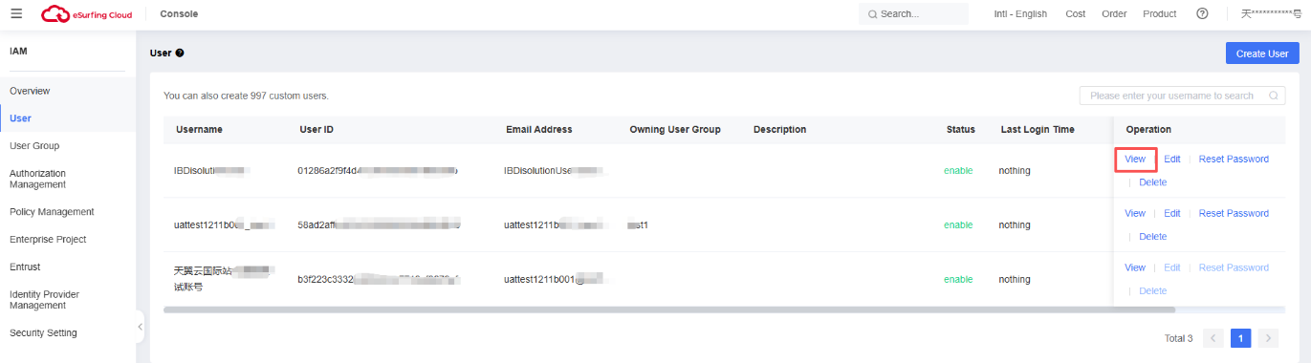
2. On the IBDisolutionUser page, click Security Setting.
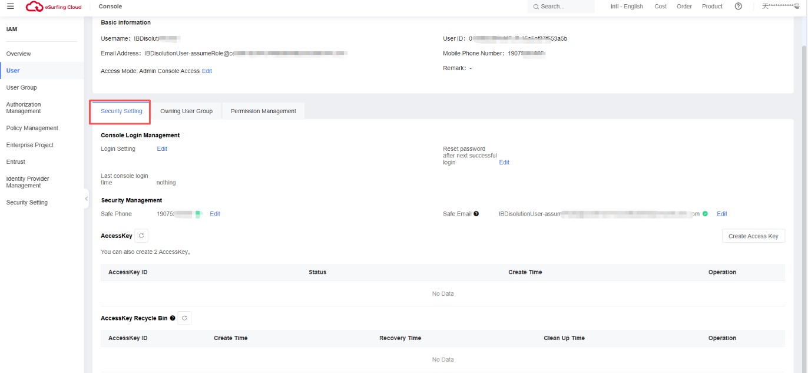
1. Click Create Access Key, then enter the verification code.
Description:
If you have bound an email or mobile phone number, a verification code is required. If neither is bound, you only need to enter your login password to create a new access key.
2. Click Confirm to generate and download the access key.
Description:
Up to 2 access keys can be created, and they are permanently valid. To ensure account security, it is recommended that you properly store and regularly rotate your access keys. To update an access key, delete the old one and generate a new one.
Deleting an Access Key
1.On the AccessKey tab, click Delete next to the target key.
2.Enter the verification code and click Confirm to delete the access key.
Description:
- If you have bound an email or phone number, you will need to enter a verification code. If you have not bound an email or phone number, you only need to enter the login password to delete the access key. Unified Scheduling of Common Pooling and Colocation: Provides scheduling capabilities of common pooling and colocation with the ECSs.
- If you find that an access key has been used abnormally (including loss, leakage, etc.), you can delete the access key yourself in My Credentials.

Viewing IAM Operation Logs
Enabling CTS
Cloud Trace Service (CTS) is a professional log auditing service in security solutions, providing collection, storage, and querying capabilities for operation records of various cloud resources. It supports common application scenarios such as security analysis, compliance auditing, resource tracking, and issue troubleshooting.
To facilitate the review of key IAM operation events—such as user creation, user deletion, and others—administrators need to enable the CTS.
Procedure
Step 1: The administrator logs in to the console.
Step 2: Select Console > Cloud Audit . If the account has not previously activated CTS, the system will redirect to the CTS authorization page. Click Consent to authorize and activate to proceed to the CTS page.
Step 3: Create a management tracker in the Guizhou region to record IAM service management operation events.
When performing IAM operations (e.g., creating users, user groups, etc.), CTS will log these activities. The table below lists the IAM-related operation events supported by CTS for recording.
Table List of IAM Operations Supported by CTS
Operation Name | Resource Type | Event Name
User Login | user | login
User Logout | user | logout
Create a User | user | createUser
Modify User Information | user | updateUser
Delete a User | user | deleteUser
Create AK/SK | user | createCredential, addCredential
Delete AK/SK | user | deleteCredential
Deactivate or Activate AK/SK | user | changeCredentialStatus
Modify AK/SK | user | updateCredential
Create a User Group | userGroup | createUserGroup
Update a User Group | userGroup | updateGroup, updateUserGroup
Delete a User Group | userGroup | deleteUserGroup
Add a User to a User Group | userGroup | addUserToGroup, updateUser/updateUserGroup
Remove a User from a User Group | userGroup | removeUserFromGroup, updateUser/updateUserGroup
Create a Delegation | agency | createAgency
Update a Delegation | agency | updateAgency
Delete a Delegation | agency | deleteAgency
Switch Role | agency | switchRole
Token | createToken
Create a Custom Policy | role | createRole
Update a Custom Policy | role | updateRole
Delete a Custom Policy | role | deleteRole
Viewing IAM Cloud Audit Logs
After enabling the eSurfing Cloud CTS service, it begins recording operational events, including those from IAM and other services. This service retains operation records for the last 7 days.
Procedure
Step 1: The administrator performs operations on the IAM Console, such as logging into the console or creating an IAM user.
Step 2: Go to the to Console view the IAM operation records.
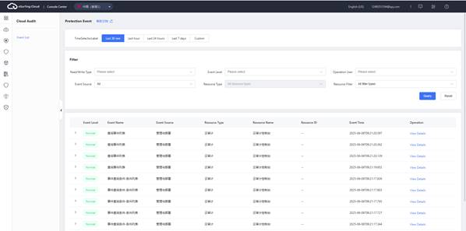
Step 3: Click to view the basic information of the event.
Step 4: Click View Events to check the event structure.

FAQs

Permission Management Category
What should I do if I cannot find the permissions for a specific service?
The eSurfing Cloud services are divided into project-specific services and global services. It is necessary to correctly select the permission scope to locate specific permissions. For example, OBS is a global service, while ECS is a project-specific service.
If you still cannot find the service after correctly selecting the service level and service name, then the service requiring permission configuration does not currently support IAM.
What should I do if the permissions are not taking effect?
After an enterprise administrator sets permissions for an IAM user on the IAM Console, the IAM sub-user may find that the permissions do not take effect upon logging into eSurfing Cloud and cannot use the services.
- Possible Cause: The administrator granted incorrect permissions to the user group to which the IAM user belongs.
Solution: The administrator should verify and modify the permissions assigned to the user group. For details, refer to User Guide > User Groups and Authorization.
- Possible Cause: The granted permissions include a denial statement for the relevant operation.
Solution: The administrator should review the details of the system permissions granted to the IAM user and check whether any deny statements exist. For details, refer to User Guide > Permission Management > Policies. If the system permissions fail to meet the requirements, the administrator can create a custom policy to allow the corresponding operation. For details, refer to User Guide > Permission Management > Custom Policies.
- Possible Cause: The administrator granted permissions to a user group but forgot to add the IAM user to the group.
Solution: The administrator should add the IAM user to the appropriate user group. For details, refer to User Guide > User Groups and Authorization > Add/Remove Users from a User Group.
- Possible Cause: For region-specific services, the administrator did not grant permissions in the corresponding region.
Solution: When assigning permissions to the IAM user group, the administrator must select the correct region. If the administrator grants permissions only for the default region project, the user can only access resources in that default project and will not have permissions for IAM sub-projects under it. It is recommended to grant the IAM user the minimum necessary regional permissions. For details, refer to User Guide > User Groups and Authorization > Create a User Group and Assign Permissions.
- Possible Cause: For region-specific services, the IAM user did not switch to the authorized region after logging into the console.
Solution: When accessing region-specific services, the IAM user must switch to the authorized region. For details, refer to User Guide > Projects.
- Possible Cause: Due to system design, OBS permissions may take 15-30 minutes to take effect after being granted.
Solution: The IAM user and administrator should wait 15-30 minutes before retrying.
- Possible Cause: Browser caching may prevent permission updates from being reflected.
Solution: Clear the browser cache and try again.
- Possible Cause: If the administrator assigns permissions in both IAM and Enterprise Management, the Enterprise Management permissions may not take effect because IAM authorization takes precedence.
Solution: The administrator should adjust the user permissions on the IAM Console as needed.
Check that rules are set for both IAM and Enterprise Management authorizations simultaneously.
When a user initiates an access request, the system performs an authorization check based on the actions defined in the user's granted access policies. The check rules are as follows:

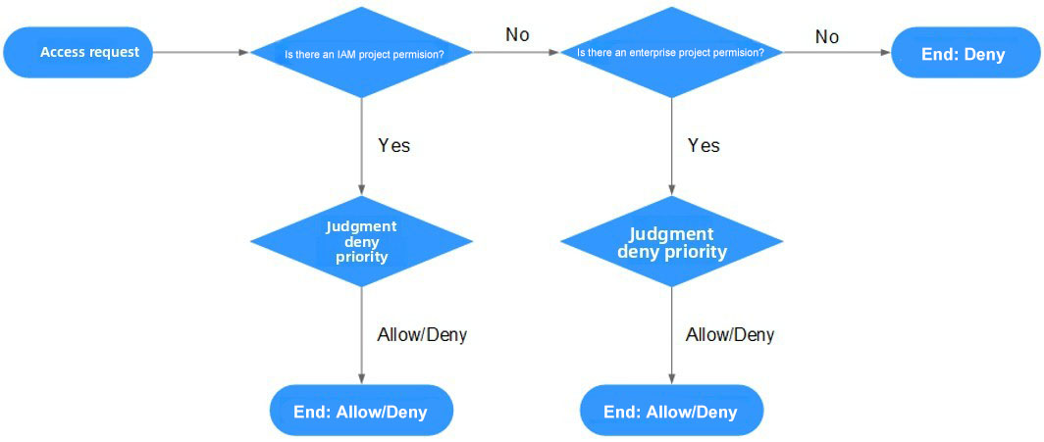
- The user initiates an access request.
- The system first searches for permissions granted based on IAM project authorization among the user's assigned access permissions, looking for the action corresponding to the request.
- If a matching action (Allow or Deny) is found, the system returns the authorization decision (Allow or Deny) for the request, and the authorization process ends.
- If no corresponding action is found in the IAM project-based permissions, the system continues to search for permissions granted based on enterprise project authorization, looking for the action corresponding to the request.
- If a matching action (Allow or Deny) is found, the system returns the authorization decision (Allow or Deny) for the request, and the authorization process ends.
- If the user has no permissions at all, the system returns the authorization decision Deny, and the authorization process ends.

Project Management Category

What are the differences between IAM and Enterprise Management?
Identity and Access Management (IAM) is an identity management service that provides identity authentication, permission assignment, access control, and other related functions.
Enterprise Management is a cloud resource management service designed for enterprise customers, aligning with multi-level organizational and project structures. It primarily includes enterprise project resource management and permission management.
Similar to IAM, Enterprise Management enables personnel management and permission assignment. However, it offers more granular resource authorization compared to IAM and is a better choice for medium and large enterprises.

Differences between IAM and Enterprise Management
- Enabling Method
  - IAM is an identity management service on the cloud platform. After system registration, it can be used free of charge without additional payment.
  - Enterprise Management is a resource management service on the cloud platform. After system registration, you need to submit a customer service ticket to request activation. Once enabled, it is free to use at no cost.
- Resource Isolation
  - IAM isolates resources across different regions by creating projects within each region. Authorization is performed on a per-project basis, allowing users to access all resources within a designated project.
  - Enterprise Management allows you to create multiple enterprise projects in a region for resource isolation. An enterprise project can contain resources from multiple regions and enables authorization for a specific resource. For example, you can add an ECS to an enterprise project, and assign permissions to a user for managing the ECS in the project instead of other ECSs.

Relationship between IAM and Enterprise Management
- The user and user group creation functions in IAM and Enterprise Management are synchronized with each other.
- After applying to enable the Enterprise Management service, when using the user group authorization feature in Enterprise Management, this function relies on IAM's policy authorization. If the system-preset policies in Enterprise Management fail to meet your requirements, you need to create a custom policy in IAM. The custom policy will be synchronized to Enterprise Management, and you can then authorize user groups with the custom policy either in IAM or Enterprise Management.
- If a user group is authorized in both IAM and Enterprise Management, the user will possess both IAM project-based policies and enterprise project-based policies. When initiating an access request, the system performs authorization checks based on the Actions defined in the user's authorized access policies.
  - If a policy contains the same Action, the effect set in IAM will prevail. For example, when a user requests to create an ECS, if the authorization result is Deny as defined in IAM, the ECS cannot be created.
IAM project strategy includes the following actions:
{
"Action": [
"ecs:cloudServers:create"
],
"Effect": "Deny"
}

Enterprise project strategy includes the following actions：
{
"Action": [
"ecs:cloudServers:create"
],
"Effect": "Allow"
}
  - If the policy contains different Actions, both the settings in IAM and Enterprise Management take effect. The following example indicates that the user can create and delete ECSs.
IAM project strategy includes the following actions：
{
"Action": [
"ecs:cloudServers:create"
],
"Effect": "Allow"
}

Enterprise project strategy includes the following actions：
{
"Action": [
"ecs:cloudServers:delete"
],
"Effect": "Allow"
}

What are the Differences Between IAM Projects and Enterprise Projects?

IAM Project
An IAM project isolates resources and services at the granularity of each eSurfing Cloud resource node, ensuring physical isolation.
There is a one-to-one correspondence between IAM projects and resource nodes. Resources within an IAM project cannot be transferred—they can only be deleted and recreated.

Enterprise Project
An Enterprise Project can be understood as an upgraded version of an IAM project, designed for grouping and managing resources across different business projects within an enterprise, providing logical isolation.
An Enterprise Project can include resources from multiple regions, and resources within the project can be migrated in or out. It enables authorization for specific cloud resources—for example, adding a particular ECS instance to an Enterprise Project and granting permissions at the project level allows controlling user access so that they can only manage that specific ECS instance.
If you enable Enterprise Management, you will no longer be able to create IAM projects.
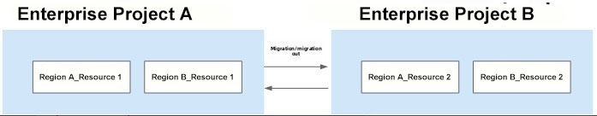
An Enterprise Project can contain resources across multiple regions, and resources within the project can be migrated in or out. It enables fine-grained authorization for specific cloud resources. For example, by adding a particular ECS instance to an Enterprise Project and configuring permissions at the project level, you can restrict users to managing only that specific ECS instance.

Regions and Availability Zones (AZs)

What are Regions and AZs?
Regions and AZs describe the physical location of data centers, allowing you to create resources in specific regions and zones.
- A region refers to a physical data center. Each region operates in complete isolation, providing maximum fault tolerance and stability. Once resources are created, their Region cannot be changed.
- An AZ is a physically isolated area within the same region, with independent power and network infrastructure, ensuring that a failure in one AZ does not affect others. A region can contain multiple AZs, which are physically isolated from each other but interconnected via an internal network. This design ensures the independence of AZs while providing low-cost, low-latency network connections.
Figure: Regions and AZs
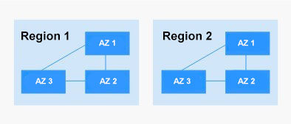

How do I select a region?
It is recommended to choose a region close to you or your target users, as this can reduce network latency and improve access speed.

How do I select an AZ?
Whether to deploy resources within the same AZ primarily depends on your requirements for disaster recovery capability and network latency.
- If your application requires high disaster recovery capability, it is recommended to deploy resources across different AZs within the same region.
- If your application demands low network latency between instances, it is recommended to create resources within the same AZ.

Delegatement Management Category

What should I do if a prompt stating "Insufficient permissions" appears when creating a delegation?

Issue Description
When an IAM user attempts to access the IAM console to create a delegation, the system prompts "Insufficient Permissions".

Causes
This IAM user does not have permission to use IAM.
The entities with IAM usage permissions are as follows:
- Account: The account can access all services, including IAM.
- Users in the admin user group: Users in the IAM default user group "admin" can access all services, including IAM.
- Users granted the "Security Administrator" or "FullAccess" permission: Users with these permissions are IAM administrators and can access IAM.

Solution
- Request the administrator to create a delegation.
- Request the administrator to grant IAM service permissions.

Key-Vault Credential Category
How do I obtain an access key AK/SK?
- If you have a login password, you can access the console. On the Console page, move the pointer to your username in the upper-right corner, select My credentials from the dropdown menu, and click the AccessKey tab. You can then view your Access Key ID (AK) in the access key list and find your Secret Access Key (SK) in the downloaded .csv file.
- If you do not have a login password and cannot access the console—such as when your access keys are lost or need to be reset—you may contact your account administrator to generate new access keys for you on the IAM and have them securely delivered to you.

What should I do if my access key AK/SK is lost?
If your Access Key (AK/SK) is lost, we recommend that you first create a new AK/SK, then replace the lost key in all applications and services with the new one.
After confirming that there is no business impact, you can safely disable or delete the lost AK/SK.
Description:
Each user can create a maximum of two access keys, and the quota cannot be increased.
If you are unable to manage your access keys, please contact your organization's account administrator for assistance.

What are temporary security credentials (temporary AK/SK and Security Token)?
Temporary security credentials are identity credentials with temporary access permissions, including a temporary AK/SK and Security Token. These credentials function almost identically to permanent security credentials, with only minor differences.

Differences Between Temporary and Permanent Security Credentials
- Temporary security credentials have a validity period, which can be set between 15 minutes and 24 hours; permanent security credentials have a permanent validity period and cannot be configured.
- There is no limit on the number of temporary security credentials; each IAM user can create up to 2 permanent security credentials.
- Temporary security credentials are obtained via API to retrieve temporary AK/SK; permanent security credentials are obtained through the My credentials console interface.
- Temporary security credentials are dynamically generated for immediate use and cannot be embedded in applications or stored. Once expired, they cannot be reused and must be reacquired.

Advantages of Temporary Security Credentials
When granting authorization to external federated users, the advantages of temporary security credentials become particularly evident. Instead of providing external federated users with permanent security credentials that require regular rotation and active revocation, you can grant them temporary security credentials that are ready for immediate use and expire after a set period. This enhances account security and adheres to the security best practice of least privilege.

Usage of Temporary Security Credentials
Temporary security credentials include temporary AK/SK and a Security Token. The temporary AK/SK and Security Token must be used together. The usage of temporary security credentials is almost identical to that of permanent security credentials. However, when authenticating with temporary security credentials, the request header must include the x-security-token field.

